Polyvagal Theory Worksheet for ADHD Women
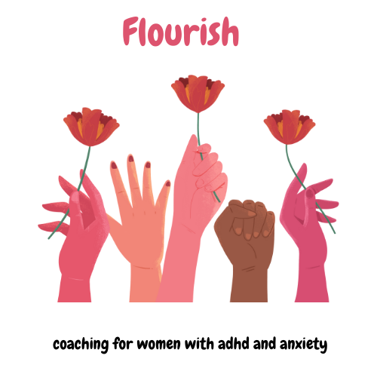

Understanding the Polyvagal Theory
The Polyvagal Theory, developed by Dr. Stephen Porges, explains how our nervous system responds to stress and relaxation. It focuses on the vagus nerve, which plays a key role in regulating the autonomic nervous system, which controls functions like heart rate, digestion, and breathing. According to this theory, our nervous system has three primary states:
Ventral Vagal State (Safe and Social): When this system is active, we feel calm, connected, and capable of engaging socially. This is the "rest and digest" state.

Sympathetic Nervous System State (Fight or Flight): In this state, our body prepares to respond to danger. This increases heart rate, muscle tension, and anxiety.

Dorsal Vagal State (Shutdown or Freeze): This state is activated when we feel overwhelmed or helpless. It can lead to feelings of numbness, disconnection, or depression.

Exercises to Stimulate the Vagus Nerve
1. The Basic Exercise 
The Basic Exercise involves lateral eye movements while holding your head in a supportive position. It is based on the idea that eye movements can influence the autonomic nervous system. Inspired by Stanley Rosenberg's work, this exercise stimulates the vagus nerve to help regulate the "rest and digest" response.
This exercise uses eye movements to send signals to your brain that you're safe. When you look to the side while holding your head still, you gently stimulate the vagus nerve, which can help calm your body down.

Women with ADHD often experience heightened anxiety and stress. This exercise can help soothe the nervous system, making it easier to manage anxiety and feel more grounded.
How To Do It:﻿


﻿

  - Sit or lie down in a comfortable position.
  - Place your hands behind your head to support it.
  - Without moving your head, look to the right with your eyes and hold for 30 seconds.
  - Please just return your eyes to the center and relax.
  - Repeat by looking to the left for 30 seconds.

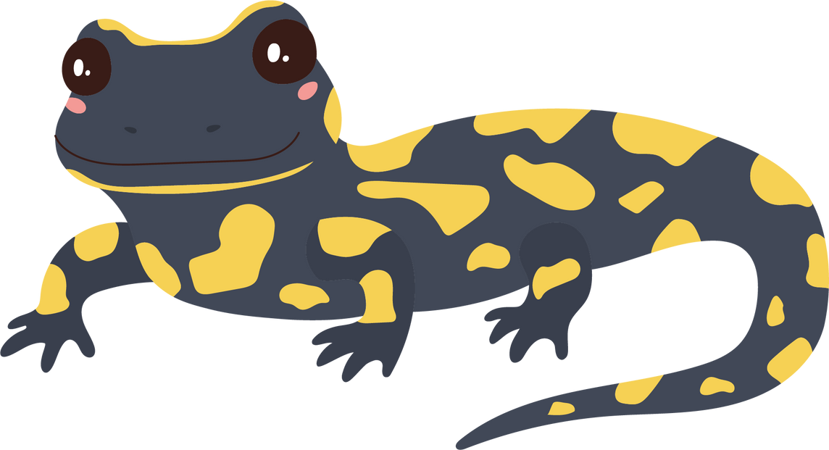

2. Seated Salamander Exercise
The Seated Salamander Exercise involves lateral eye movements and a slight head tilt to engage neck muscles. It is another adaptation from Rosenberg's work on the vagus nerve. The combination of eye movement and head tilt may increase vagal tone, improving relaxation and recovery from stress.
This exercise combines eye movements with a gentle neck stretch, sending calming signals to your brain. It helps relax both your mind and body.
ADHD women often struggle with muscle tension and anxiety. This exercise helps release tension in the neck and shoulders, promoting a sense of calm.
How to Perform the Exercise

  - Sit in a comfortable chair with your back straight.
  - Slowly tilt your head to the right while keeping your eyes level.
  - Look to the left with your eyes and hold for 30 seconds.

  - Return your head and eyes to the center and relax.
  - Repeat on the other side by tilting your head to the left and looking to the right.

3. Sphinx with Head Turn
The Sphinx with Head Turn exercise combines a gentle backbend with lateral head movements. The backbend helps open the chest, improving posture and breathing, while the head turn continues to engage the vagus nerve. This exercise reduces anxiety by combining physical stability with gentle vagal stimulation.
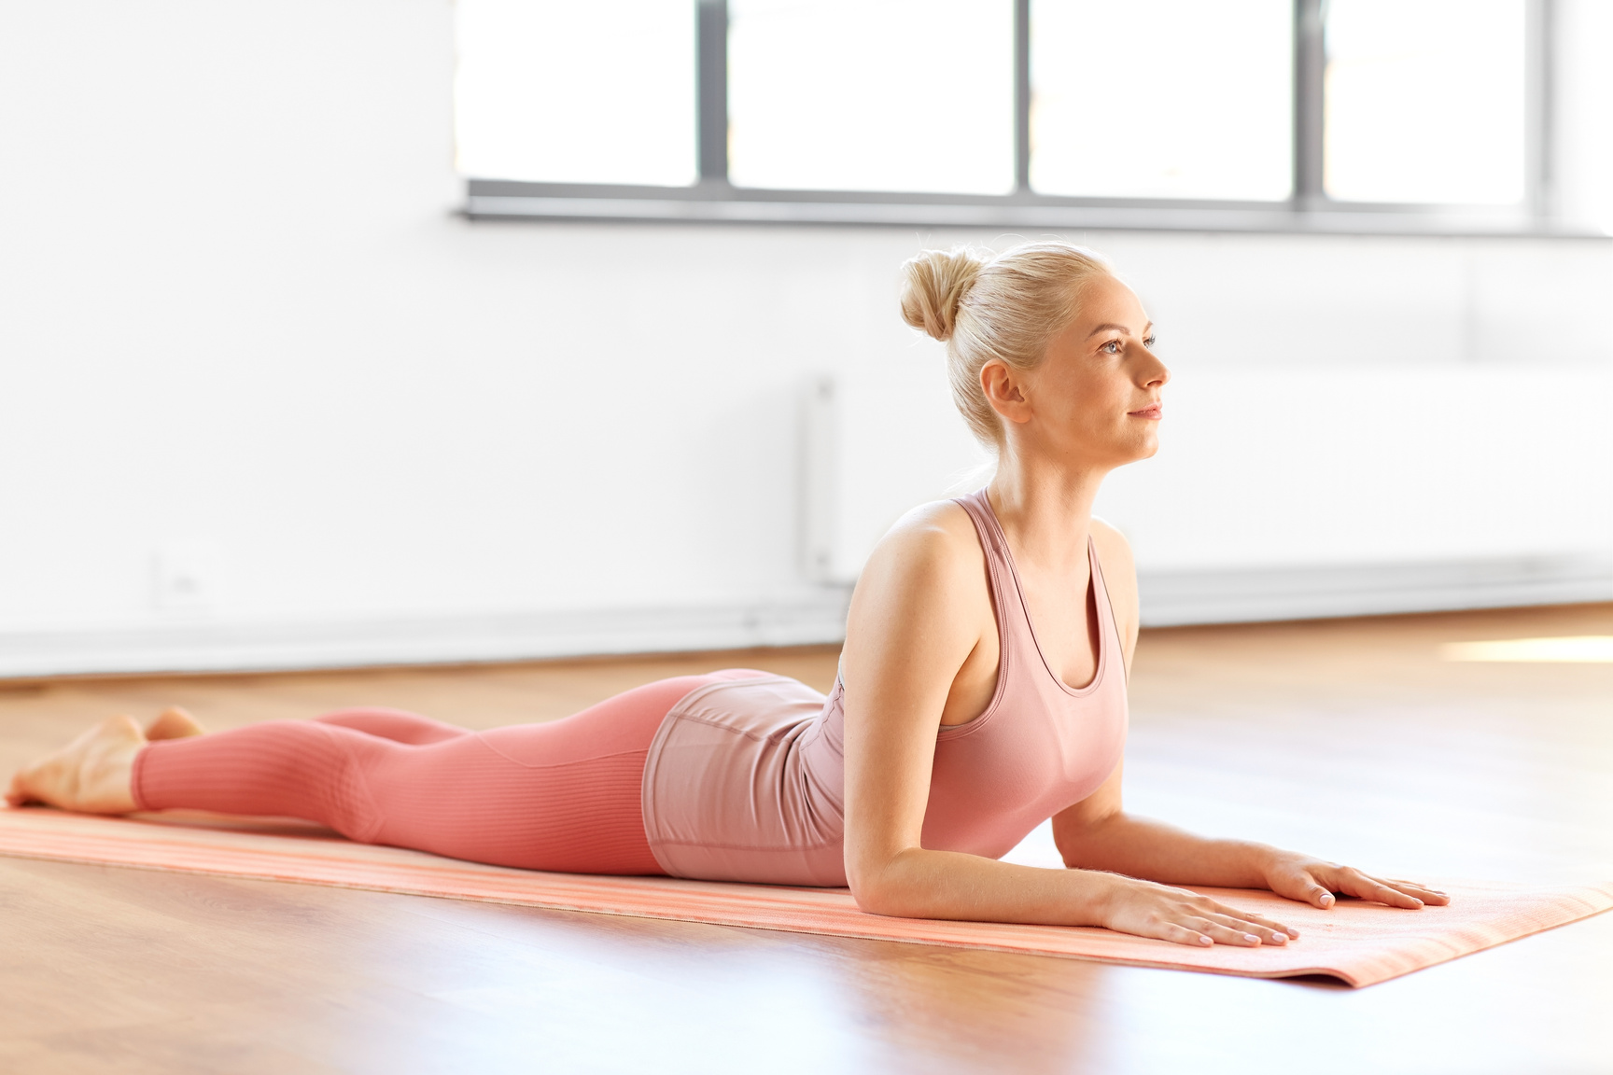
By lying on your belly and turning your head, this exercise helps open up your chest and gently stimulates your vagus nerve. This can help you feel more relaxed and reduce feelings of anxiety.
Women with ADHD often deal with physical restlessness and mental stress. This exercise provides a way to calm the body while also helping to clear the mind, making it easier to focus and feel more at ease.
How to Perform the Exercise:
  - Lie on your belly with your forearms on the ground and your elbows directly under your shoulders (this is the Sphinx position in yoga).
  - Gently lift your head and chest off the ground, opening your chest.
  - Slowly turn your head to the right and hold for 30 seconds.
  - Please just return your head to the center and relax.
  - Please just repeat by turning your head to the left for 30 seconds.
Why These Exercises Help ADHD Women
Regulation of the Nervous System
Women with ADHD often experience dysregulation of their nervous systems, leading to heightened anxiety, stress, and physical tension. These exercises help to stimulate the vagus nerve, which is critical in calming the nervous system. Activating the vagus nerve promotes relaxation and reduces the body's stress response.
Reduction of Anxiety
Anxiety is a common symptom among women with ADHD. By practicing these exercises, you can help mitigate anxiety by promoting a sense of safety and calm within the body, which is essential when dealing with hyperactivity and restlessness.
Improvement of Focus
ADHD often makes it difficult to maintain focus and attention. These exercises can help ground you by reducing internal chaos, making it easier to concentrate on tasks.
Physical Relaxation
These exercises release tension in areas where stress is commonly held, such as the neck and shoulders. Reducing physical tension can improve overall well-being and a greater ability to manage ADHD symptoms.

Reflection and Practice Log
Daily Practice Log
Date | Exercise Completed | Duration | Notes on How You Felt Before and After

Reflection Questions
- How did your body feel before and after each exercise?

- Did you notice any changes in your anxiety or focus after completing the exercises?

- How easy or difficult was incorporating these exercises into your daily routine?

Summary
These exercises are gentle, easy to incorporate into your daily routine and offer a practical way to manage anxiety, stress, and physical tension. By regularly practicing these exercises, you can take control of your ADHD symptoms, leading to better overall well-being.

Next Steps: Practice these exercises daily and use the reflection log to track your progress. Consider sharing your experiences with a healthcare provider to support your ADHD stress management further.

