Cardiff Park Series 2026 – Event Details
Pentwyn – Wednesday 22nd July 2026
Location | Registration and assembly is at the rear of Pentwyn Leisure Centre, Bryn Celyn Road.  What 3 Words: ///hook.change.spike  Google Maps: https://maps.app.goo.gl/HmcHJYkkNNKi1raM6  Postcode: CF23 7EZ
Getting There | If you are cycling, there is a metal fence at assembly where you can lock your bike.  By bus, Cardiff Bus No. 58, stop is Pentwyn Leisure Centre.  If you are driving, Pentwyn Leisure Centre Car Park is still free whilst the leisure centre is being redeveloped.
Entries | Entries online via Fabian4. Entries only available on the day if there are spare maps.  https://www.fabian4.co.uk/start/list.aspx?EventID=4231
Starts | Starts will be open between 5:30pm and 7pm. Starts will be at one minute intervals.  If you are new to the sport and want some initial coaching, please arrive early and someone will be there to show you the basics.
Courses | 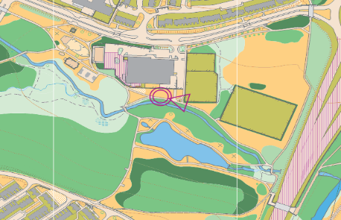  All courses utilise a bran new mapped area for 2026, this will be our first Park Series Event held in Pentwyn.  Juniors, under 16, can run the Short and Middle courses, but not the Long due to road crossings.  Short Course  The short course is about 1.6km and stays within the confines of Parc Coed Y Nant, behind Pentwyn Leisure Centre. We would suggest that all novices try this course first before running one of the longer courses.  Medium Course  The medium course is about 3km and utilises both Parc Coed Y Nant and the adjacent Parc Waun Fach. The course utilises 2 underpasses under the road to pass between the parks to avoid crossing over the road.  Long Course  The long course is about 6.3km direct line and will extend beyond the parks and through residential areas of Pentwyn and Llanedeyrn. A number of underpasses are available to avoid most road crossings, but not all.
What to Wear | Most of you will want to wear normal running gear. If you intend to walk then stout shoes will do. You will mostly be running/walking on tarmac, graded paths, gravel and grass, but it could be muddy, so come prepared.  If you have a compass, you can bring it, but you do not normally need one for this kind of racing.  Bring a waterproof if it looks like being wet.
Maps | The map is a special sprint orienteering map prepared at a scale of 1:5,000. One centimetre is the equivalent of 50m. Courses will be on waterproof paper.
Children Under 10 | Children under 10 are welcome to take part on the novice course. However, a responsible person should accompany them.
Cost of Running | The cost to run will be:  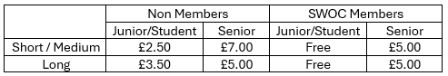  Pairs / Groups going round together - for those wishing to go round together using one Si Dibber (timing device) enter the pair/group leader as a solo entrant and specify the names of the others in the group in the special request box. One map will be provided but you ca order  extra maps @ £1 in the Event Options section below.  Minimum age 16 for the Long course - The Long course crosses major roads and is for over 16s only, unless accompanied by an adult.  Free runs for Junior and Student Members - Join SWOC for £6.20 (age 20-) or £12.20 (age 21-25) for the year and run the whole Park Series and some other SWOC events for free.  Reduced Fees for Senior Members - Join SWOC for £20 (age 26+) and save £2 per event on the Long course and at most other orienteering events.  Families with children who want to run together will be charged Junior rate.  If you want to join SWOC follow the link below stating SWOC as the club you wish to join.  https://www.britishorienteering.org.uk/join_online
Results | Results and league positions will be posted on the SWOC website.  http://www.SWOC.org.uk
For anyone who has not tried the sport before | 7 steps to completing your first course not tried the sport  before  1 - Register at enquires (the table at the tent) where you will be given a small Ecard you put on your finger and use to confirm you have visited all the controls.  2 - Ask any questions you may have. One of the helpers will talk you through the novice course and explain what the key symbols on the map mean.  3 - Go to the start where you will be given your map and told when you can start.  4 - Punch the start control. If you do not you will not have a time for the race.  5 - Look at your map and plan how you will get to the first control. Run/walk as fast as you can to the first control. Do not run faster than you can navigate. Keep your map orientated (facing where you are going). Keep track of  where you are as you run. Punch the first control with your e-card.  5 - Complete the rest of the course, remembering to punch at each control and the finish.  6 - Go back to enquiries to download, get your results and return your e-card.  7 - Make a note of when the next race is.
Photography Policy | You are welcome to take photographs or record video at this event, but please respect people’s privacy. Photographs may be posted on the internet. If there are particular reasons why an individual should not be photographed, please discuss the issue with the organiser in advance of the event. Report any concerns about inappropriate photography to the event organiser.
Organiser: | Andrew Firth 07816902281

