Introduction
This guide provides instructions for using the admin page of the YUTH app, which allows administrators to view and edit course and user information. The admin page is primarily used for adding new courses or modifying existing ones.

Navigating the Admin Site

Log In
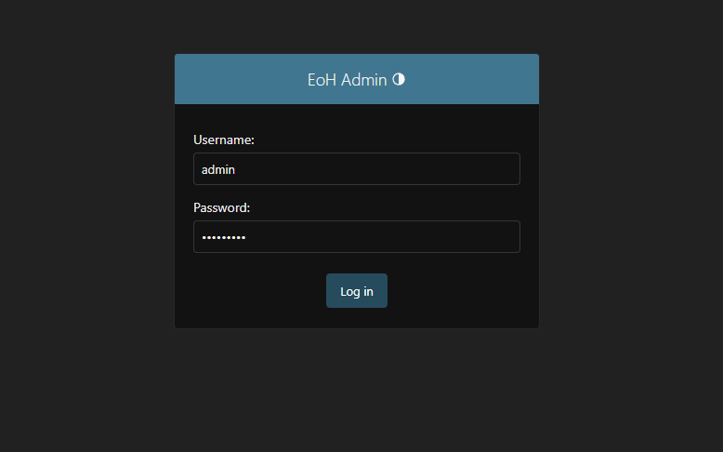
  - Access the admin site here.
  - Log in using your assigned credentials.

Home Page
  - Once logged in, you will be directed to the home page.
  - The home page displays:
    - All available data tables
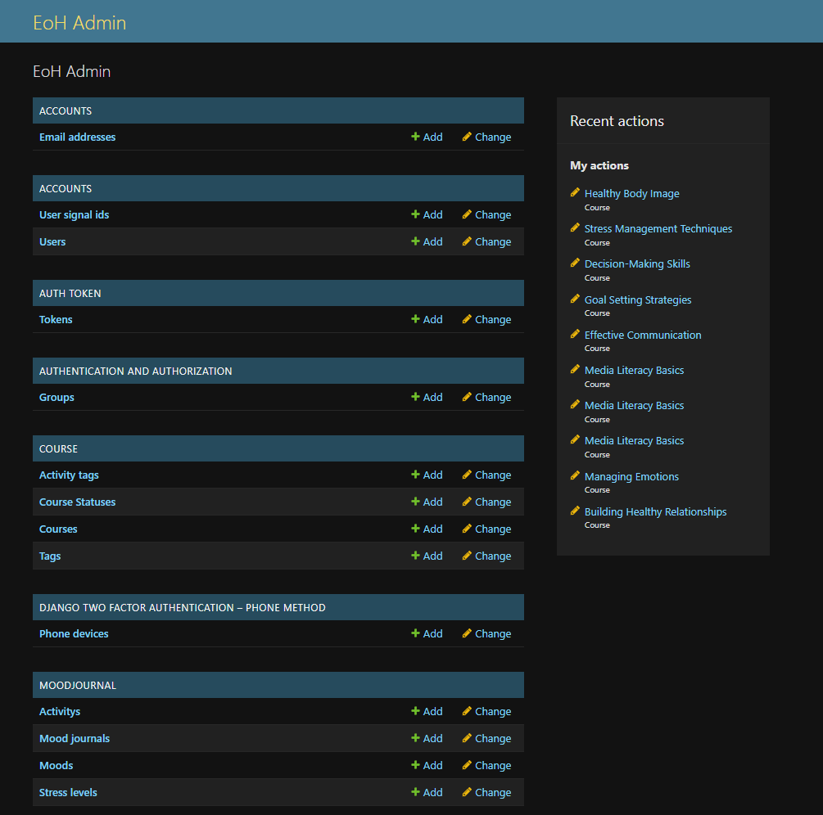
    - A summary of recent edits (Top-left corner).

Viewing Tables
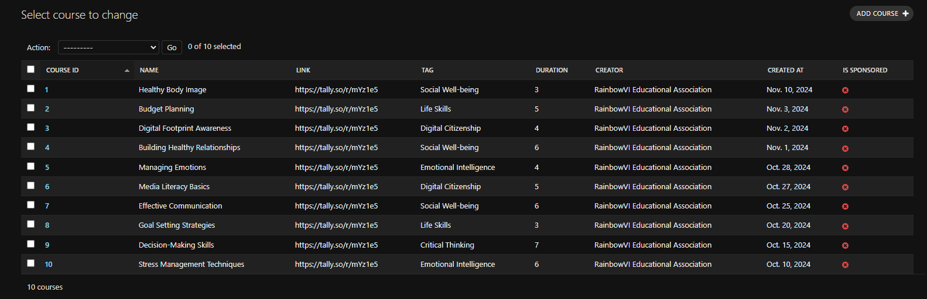
  - Click on the name of any data table (e.g., “Courses”) to view its contents.

Sidebar Navigation
  - Use the left-hand sidebar to navigate between tables.
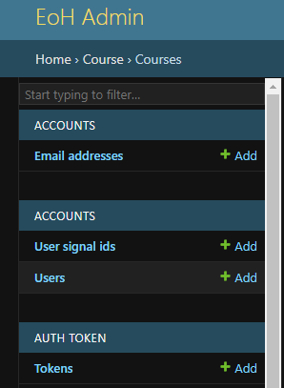
  - Click Home (top-left) to return the the home page at any time.

Adding New Courses
Prerequisites:
- Logged in to the admin site
- Access to a valid Tally form.

Steps:
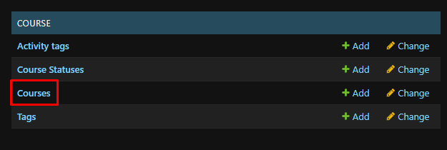
- Click on Courses. This can be done from the homepage, or the sidebar.
- Click the ADD COURSE button on the top-right of the screen.

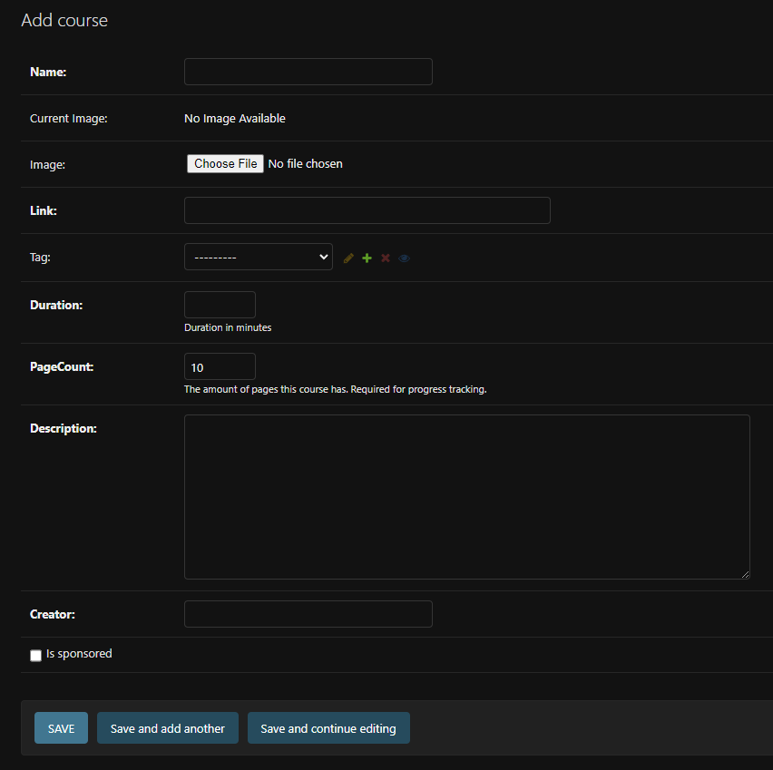
- You will now see an empty form for the course information. Fields may have a short description below them, explaining how that field works. PageCount for example, requires an accurate number in order to track progress properly.


- To fill in the Link field, you will need a valid tally url. To get this, first head to Tally and log in. You will then see the dashboard with all of the available forms.

- Select the form you want, and click Share.
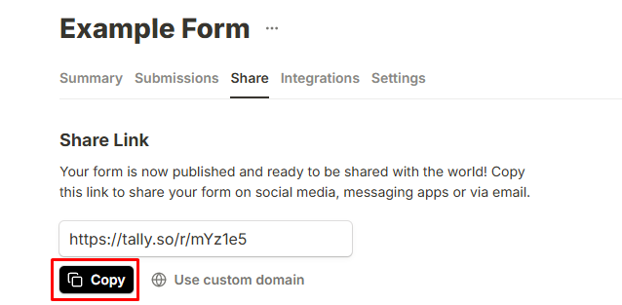
- Click Copy on the share link.

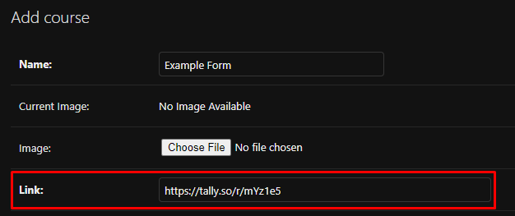
- Return to the admin page, and paste the url in the Link field.
- When selecting a Tag for the course, a dropdown will appear, allowing you to select what this course falls under.
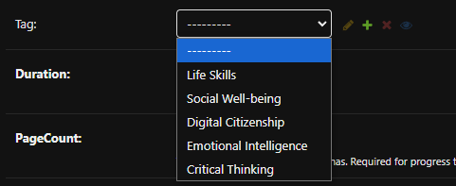
- If an appropriate tag is not available, click the Plus Icon.

- Enter a name for your new tag, and click Save. This will select the new tag for the course.
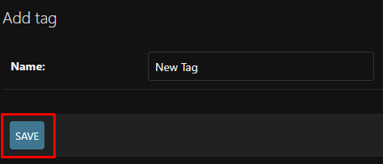
- Fill out the remainder of the course information. Ensure all information is complete, as saving the course will add it to the database, making it immediately available to all users.
- Click SAVE to add the course to the database.

Editing a Course
Prerequisites:
- Logged in to the admin site
- The course you want to edit exists.
Steps:
- Click on Courses. This can be done from the homepage, or the sidebar.
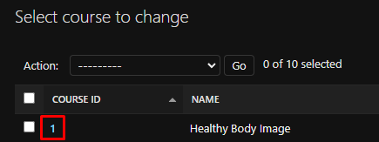
- Select a course you wish to edit. This can be done by selecting the ID Number of the course.

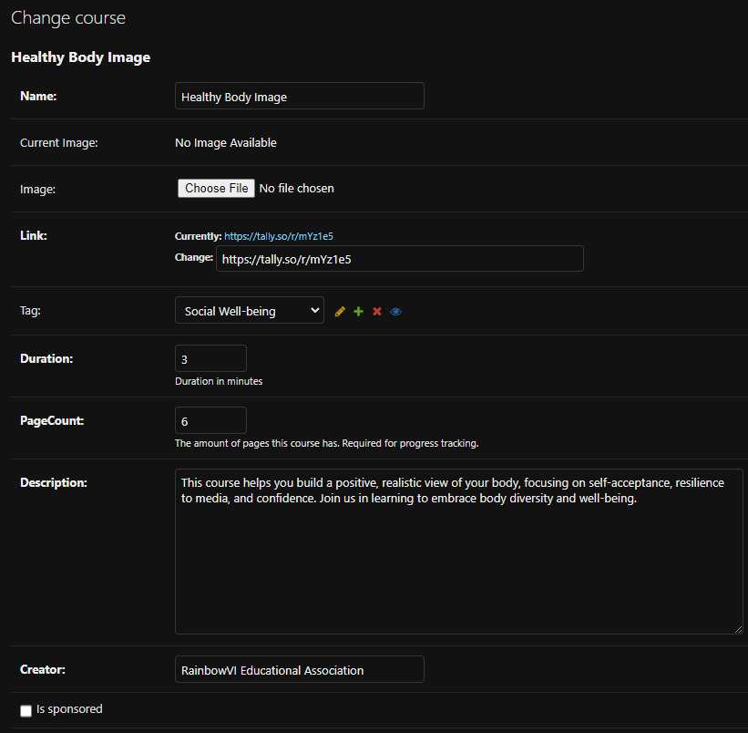
- Here, all of the information regarding the course will be displayed. You can make changes to any aspect of the course.

- Once your changes have been made, click SAVE.

Adding new Tags
Prerequisites:
- Logged in to the admin site

Steps:
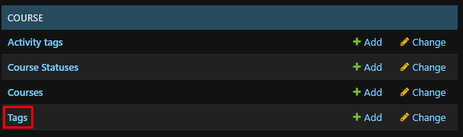
- Click on Tags. This can be done from the homepage, or the sidebar.
- Click ADD TAG.
- Enter the name of the new tag, and click SAVE.
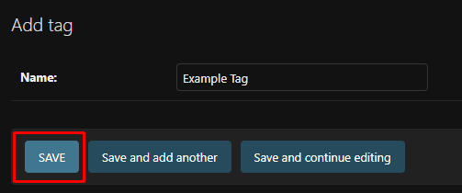

Editing Tags
Note: Editing an existing tag will automatically update all associated courses.
Prerequisites:
- Logged in to the admin site
Steps:
- Click on Tags. This can be done from the homepage, or the sidebar.
- Click on the Name of the tag you wish to edit.
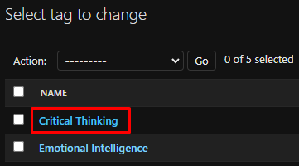
- Enter the new name, and click SAVE.

