Course Recommendation Logic Documentation

Overview
The course recommendation system provides personalized course suggestions based on user's mood journals. If no stress-related mood journal is available, it falls back to default recommendations.

Chart
Below is a high-level chart of how the recommendation logic works.
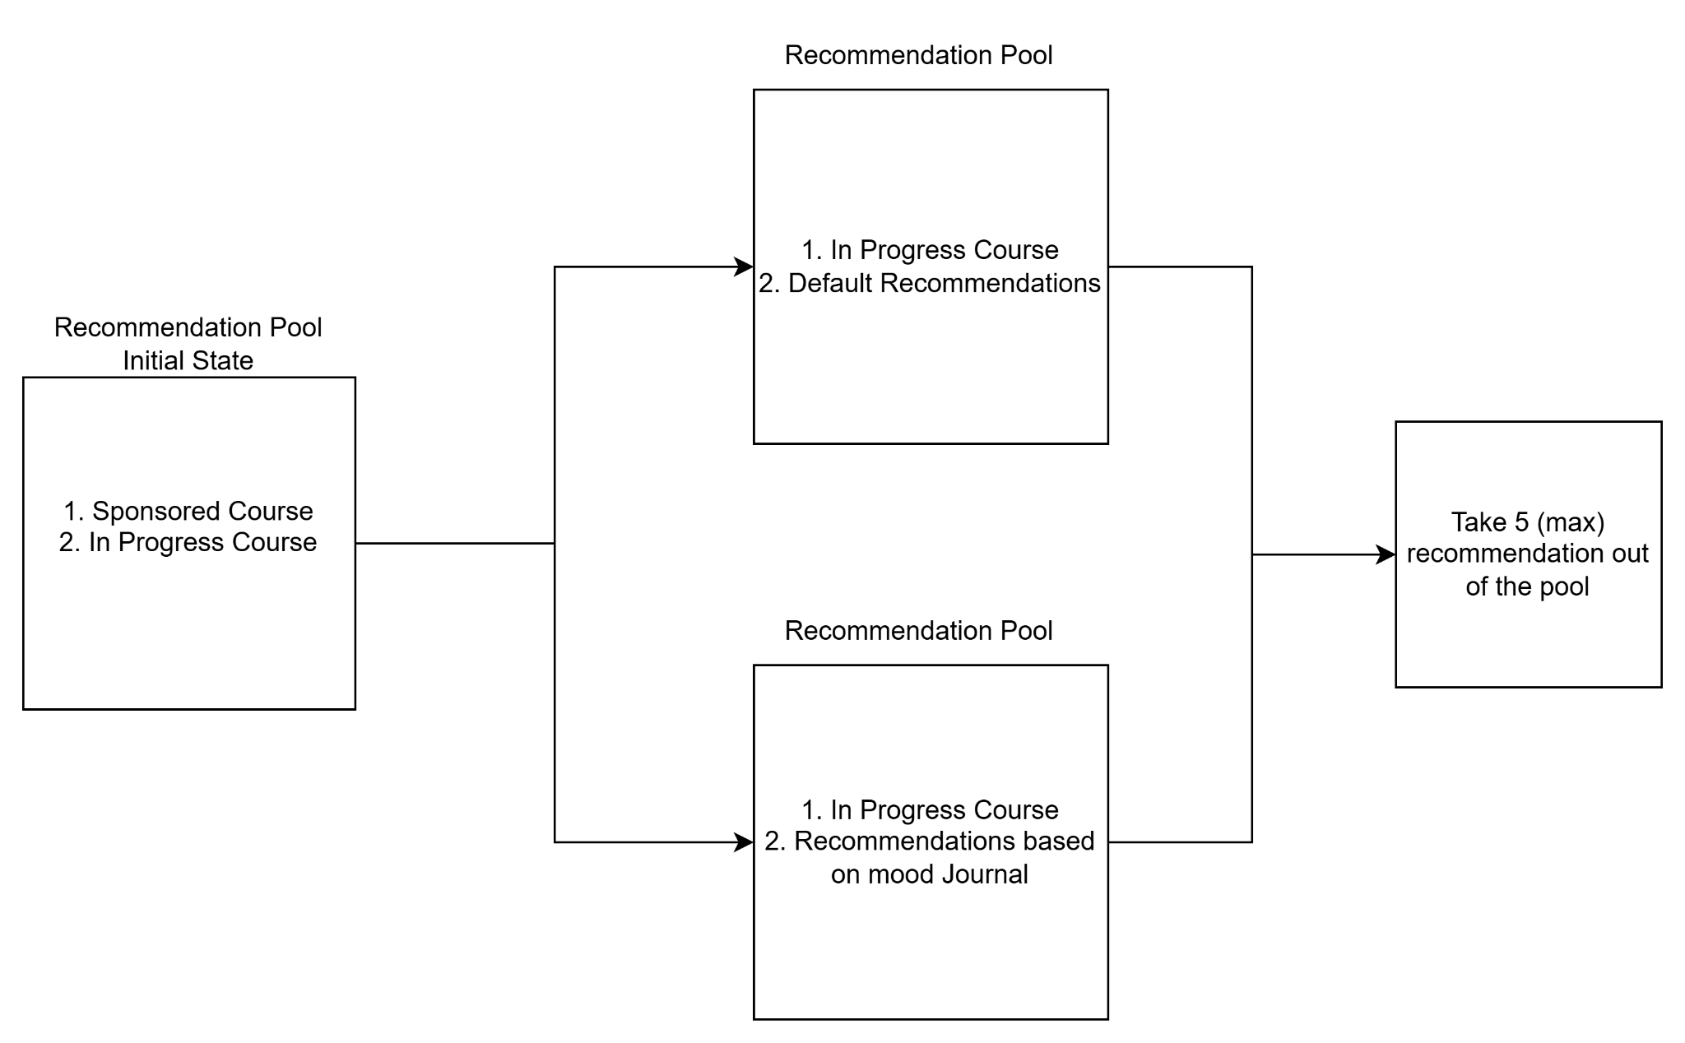

Main Components

1. Data Sources
- Courses
- Mood Journals
- Activity_tag_link table

2. Recommendation Process

Step 1: In-Progress Courses and sponsored courses
Always includes sponsored courses and user's current in-progress courses in recommendations and they should be placed in the front

Step 2: Stress-Based Recommendations
1. Analyzes last 5 mood journal entries
2. Identifies journals with 'High stress' or 'Medium stress' levels
3. Extracts activities from stressed moments
4. Maps activities to tags through ActivityTag model
5. Recommends courses with matching tags
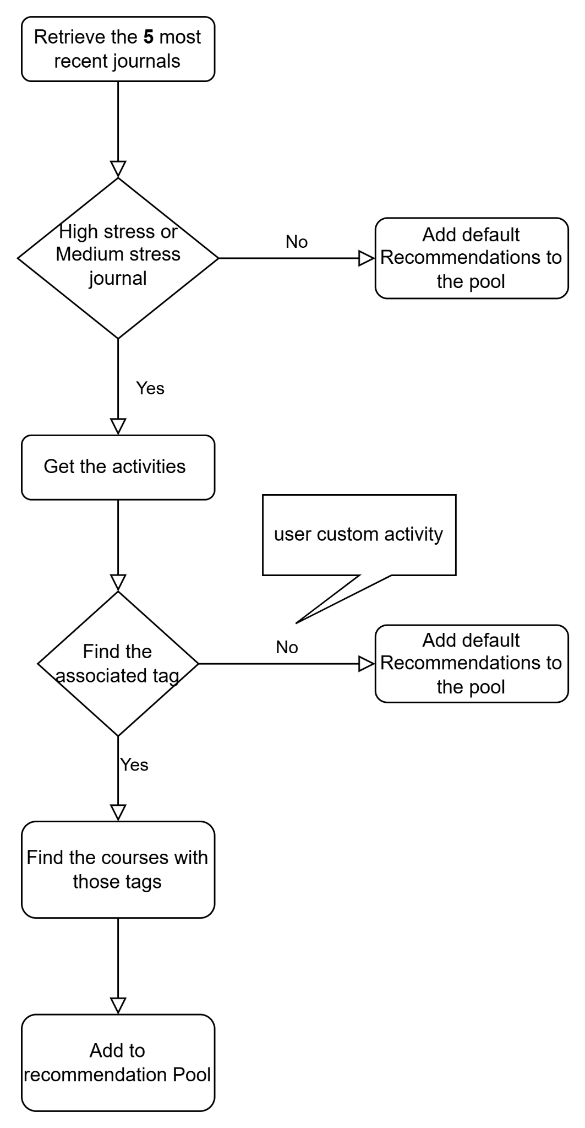
Below is the summarized flow chart for this process

Step 3: Fallback Logic
If no stress data or relevant tags are found, system falls back to default recommendations:
- Excludes in-progress courses as they are already included in the in-progress courses
- Returns 5 random courses

Response Format
- Success Response: returns course recommendations prioritized with sponsored courses and in-progress courses placed at the top, followed by additional suggestions tailored to the user's mood journal entries.

{
"success": true,
"data": {
"recommendations": [
{
"course_id": 1,
"name": "Healthy Body Image",
"image_url": "http://localhost:8000/media/course_images/e2e33b3301a9e3f72049c65aaf0777b4.png",
"link": "https://tally.so/r/mYz1e5",
"tag_id": 2,
"tagName": "Social Well-being",
"duration": 3,
"pageCount": 10,
"description": "This course helps you build a positive, realistic view of your body, focusing on self-acceptance, resilience to media, and confidence. Join us in learning to embrace body diversity and well-being.",
"creator": "RainbowVI Educational Association",
"created_at": "2024-11-10",
"is_liked": false,
"course_progress": "In Progress",
"progress": 1,
"is_sponsored": true
},
{
"course_id": 3,
"name": "Digital Footprint Awareness",
"image_url": null,
"link": "https://tally.so/r/mYz1e5",
"tag_id": 3,
"tagName": "Digital Citizenship",
"duration": 4,
"pageCount": 10,
"description": "This course encourages safe and responsible online behaviors by teaching about digital footprints, privacy, and media literacy. Develop critical thinking skills to navigate the digital world with confidence.",
"creator": "RainbowVI Educational Association",
"created_at": "2024-11-02",
"is_liked": false,
"course_progress": "In Progress",
"progress": 2,
"is_sponsored": false
},
{
"course_id": 4,
"name": "Building Healthy Relationships",
"image_url": null,
"link": "imnotareal.url",
"tag_id": 2,
"tagName": "Social Well-being",
"duration": 6,
"pageCount": 10,
"description": "Explore the foundations of respectful, positive relationships in this course, including communication, trust, and boundaries. Gain insights into fostering connections that support well-being and mutual respect.",
"creator": "RainbowVI Educational Association",
"created_at": "2024-11-01",
"is_liked": false,
"course_progress": "Not Started",
"progress": 0,
"is_sponsored": false
},
],
"based_on": {
{
"activities": [
"Relationship"
],
"stress_level": "Medium stress",
"tags": [
"Social Well-being"
]
}
]
}
}
}

- Fallback responses: returns 5 random course recommendations, prioritizing sponsored courses and in-progress courses at the top.
{
"success": true,
"data": {
"recommendations": [
{
"course_id": 1,
"name": "Healthy Body Image",
"image_url": "iamnotreal.url",
"link": "https://tally.so/r/mYz1e5",
"tag_id": 2,
"tagName": "Social Well-being",
"duration": 3,
"pageCount": 10,
"description": "This course helps you build a positive, realistic view of your body, focusing on self-acceptance, resilience to media, and confidence. Join us in learning to embrace body diversity and well-being.",
"creator": "RainbowVI Educational Association",
"created_at": "2024-11-10",
"is_liked": false,
"course_progress": "In Progress",
"progress": 1,
"is_sponsored": true
},
{
"course_id": 3,
"name": "Digital Footprint Awareness",
"image_url": null,
"link": "https://tally.so/r/mYz1e5",
"tag_id": 3,
"tagName": "Digital Citizenship",
"duration": 4,
"pageCount": 10,
"description": "This course encourages safe and responsible online behaviors by teaching about digital footprints, privacy, and media literacy. Develop critical thinking skills to navigate the digital world with confidence.",
"creator": "RainbowVI Educational Association",
"created_at": "2024-11-02",
"is_liked": false,
"course_progress": "In Progress",
"progress": 2,
"is_sponsored": false
},
{
"course_id": 8,
"name": "Goal Setting Strategies",
"image_url": null,
"link": "imnotareal.url",
"tag_id": 1,
"tagName": "Life Skills",
"duration": 3,
"pageCount": 10,
"description": "Develop a framework for setting and achieving personal goals. This course covers goal prioritization, time management, and motivation to help you reach your objectives effectively.",
"creator": "RainbowVI Educational Association",
"created_at": "2024-10-20",
"is_liked": false,
"course_progress": "Not Started",
"progress": null,
"is_sponsored": false
},
{
"course_id": 4,
"name": "Building Healthy Relationships",
"image_url": null,
"link": "imnotareal.url",
"tag_id": 2,
"tagName": "Social Well-being",
"duration": 6,
"pageCount": 10,
"description": "Explore the foundations of respectful, positive relationships in this course, including communication, trust, and boundaries. Gain insights into fostering connections that support well-being and mutual respect.",
"creator": "RainbowVI Educational Association",
"created_at": "2024-11-01",
"is_liked": false,
"course_progress": "Not Started",
"progress": 0,
"is_sponsored": false
},
{
"course_id": 1,
"name": "Healthy Body Image",
"image_url": "imnotareal.url",
"link": "https://tally.so/r/mYz1e5",
"tag_id": 2,
"tagName": "Social Well-being",
"duration": 3,
"pageCount": 10,
"description": "This course helps you build a positive, realistic view of your body, focusing on self-acceptance, resilience to media, and confidence. Join us in learning to embrace body diversity and well-being.",
"creator": "RainbowVI Educational Association",
"created_at": "2024-11-10",
"is_liked": false,
"course_progress": "In Progress",
"progress": 1,
"is_sponsored": true
}
],
"based_on": "Default recommendations (no stressed journals found)"
}
}
Limitations

- The order of the recommendations is randomized: beyond the in-progress courses, the suggested courses are presented in a random order. All recommended courses carry equal weight, with no prioritization based on factors such as course popularity or course completion rates etc..
- The activity-tag matching system is manual: it relies on a predefined mapping between activities and tags rather than using dynamic tag generation or machine learning. Consequently, if a user adds a custom activity, the mapping table must be updated manually to maintain accurate recommendations.

