YUTH
Documentation
RainbowVi
Ruby Chen
Daniel McRae
Yerim Moon
Chelsea Yang

Project Description 2
Goals 2
Project Overview 3
Source Control 3
Tech Stack 3
Current Functionality 4
Frontend 5
Code Structure 5
Components 11
Navigation 13
Backend - Ruby 14
Code Structure 14
Classes and Models 15
Views 16
Future Considerations 18
Known Issues and Limitations 18
Planned Features 19
Diagrams 21
Entity Relation Diagram 21
Flow Diagram 21

Introduction

This document serves as a guide for understanding the scope, objectives, and functionality of the YUTH (Youth Unleashing Their Horizon) project, an initiative by the RainbowVI Educational Association. It is intended for stakeholders, including developers, project managers, and organizational leaders, to align on the goals and expectations of the project. Additionally, it provides an overview of the implemented features and functionality of the project.

Project Description
The YUTH project delivers bite-sized educational content and interactive tools to support life skill development and emotional well-being. The key features include mood tracking, allowing users to record and review their recent moods, and mini-courses designed to provide knowledge in many aspects of life.

Goals
The YUTH app aims to:
- Empower youth with essential life skills and self-improvement resources.
Enhance emotional well-being through mood tracking tools.
- Equip young people with practical knowledge for real-world challenges through courses.
- Advocate for personal and professional growth of youth, in alignment with the RainbowVI Educational Association’s mission.

Project Overview

Source Control
This project utilizes two GitHub repositories:
- Frontend Repository: Handles user interaction, app routing, and the overall user experience.
Repository URL: https://github.com/rainbowvi/frontend
- Backend Repository: Manages API interactions, database connectivity, and any other computational resources that run server-side.
Repository URL: https://github.com/RainbowVI/backend

The main branch in both repositories contains the live build. Development follows a branching strategy to ensure clean and organize version control, and uses the following naming conventions:
- Feature branches: feature/branchname
- Bugfix branches: bugfix/branchname
- Refactor branches: refactor/branchname

Tech Stack
Frontend:
- React: User interface and interaction
- Javascript: Core logic for features
- Tally.so: Course integration and progress tracking
Backend:
- Django: Server framework for backend development
- Django Rest Framework (DRF): Builds and manages API endpoints
- Python: Powers backend operations and logic
- Docker: Used to ensure consistent development and deployment environments

Database:
- PostgreSQL: Stores and manages all app-related data

Current Functionality
MoodJournal
- Create New Entries: Add a mood, stress level, and activity, with an automatic timestamp for easy tracking.
- Delete Entries: Remove entries if they are not needed.
- Custom Activities: Create personalized activities with a name and icon if the predefined activities don’t suit your needs.
- View Recent Moods: Quickly see the last five moods logged on the home page.

Courses
- Take Courses: Explore topics related to self-improvement and well-being, with the ability to stop and resume progress.
- Track Progress: Ensure smooth continuation of partially completed courses.
- Recommend Courses: Receive suggestions based on recent Mood Journal entries.
- Like Courses: Mark courses to easily find them later.
- Search Courses: Locate courses by name or tag.

Frontend

Code Structure
The frontend code is organized into two main directories:
1.src/commons: This folder contains reusable components and navigation components.
2.src/pages: This folder contains the app’s page-specific components for the app.

Each component is organized into its own folder, which includes:
- A __test__ folder for test files.
- A components subfolder (if the component includes additional subcomponents).
  - If a subcomponent requires testing, the test files are located in the components/__test__.
- A styles.js file for the component’s styling.

The images are located in the following directories: src/images/activity-icons, src/images/course, and src/images/stress-images.

src/commons
├── BasicButton
│ ├── index.jsx
│ └── styles.js
├── CourseCard
│ ├── __test__
│ │ └── CourseCardTest.test.js
│ ├── index.jsx
│ └── styles.js
├── CourseCarousel
│ ├── __test__
│ │ └── CourseCarouselTest.test.js
│ ├── index.jsx
│ └── styles.js
├── CourseSearch
│ ├── __test__
│ │ └── CourseSearch.test.js
│ ├── components
│ │ ├── SearchTags
│ │ │ ├── SearchTags.jsx
│ │ │ └── styles.js
│ │ └── __test__
│ │ └── SearchTags.test.js
│ ├── index.jsx
│ └── styles.js
├── Navbar
├── __test__
│ └── navbar.test.js
├── index.jsx
└── styles.js

src/pages
├── Activity
│ ├── __test__
│ │ └── activity.test.js
│ ├── components
│ │ ├── ActivityFooter
│ │ │ ├── ActivityFooter.jsx
│ │ │ ├── api.js
│ │ │ └── styles.js
│ │ ├── ActivityIcons
│ │ │ ├── ActivityIcons.jsx
│ │ │ ├── api.js
│ │ │ ├── icons.jsx
│ │ │ └── styles.js
│ │ └── __test__
│ │ ├── activityfooter.test.js
│ │ ├── activityicon.test.js
│ │ ├── api.test.js
│ │ └── icons.test.js
│ ├── index.jsx
│ └── styles.js
├── AddActivity
│ ├── __test__
│ │ └── addactivity.test.js
│ ├── component
│ │ ├── AddActivityFooter
│ │ │ ├── api.js
│ │ │ ├── index.jsx
│ │ │ └── styles.js
│ │ ├── AddActivityHeader
│ │ │ ├── index.jsx
│ │ │ └── styles.js
│ │ ├── AddActivityIcon
│ │ │ ├── icons.jsx
│ │ │ ├── index.jsx
│ │ │ └── styles.js
│ │ └── __test__
│ │ ├── addActivityFooter.test.js
│ │ ├── addActivityHeader.test.js
│ │ ├── addActivityIcon.test.js
│ │ └── api.test.js
│ ├── index.jsx
│ └── styles.js
├── Course
│ ├── __test__
│ │ └── course.test.js
│ ├── components
│ │ ├── CourseCardDesktop
│ │ │ ├── CourseCardDesktop.jsx
│ │ │ └── styles.js
│ │ ├── CourseNoCarousel
│ │ │ ├── CourseNoCarousel.jsx
│ │ │ └── styles.js
│ │ └── __test__
│ │ ├── CourseCardDesktop.test.js
│ │ └── CourseNoCarousel.test.js
│ ├── index.jsx
│ └── styles.js
├── CourseDetail
│ ├── __test__
│ │ └── index.test.js
│ ├── components
│ │ ├── __test__
│ │ │ ├── modal.test.js
│ │ │ └── progressbar.test.js
│ │ ├── modal.jsx
│ │ └── progressbar.jsx
│ ├── index.jsx
│ └── style.js
├── CourseIntro
│ ├── __test__
│ │ └── index.test.js
│ ├── index.jsx
│ └── style.js
├── Home
│ ├── Components
│ │ ├── AddNewMood.jsx
│ │ ├── RecentMoodsCard.jsx
│ │ ├── RecentMoodsTitle.jsx
│ │ └── __test__
│ │ ├── AddNewMood.test.js
│ │ ├── RecentMoodsCard.test.js
│ │ └── RecentMoodsTitle.test.js
│ ├── __test__
│ │ └── home.test.js
│ ├── index.jsx
│ └── styles.js
├── Login
│ ├── __test__
│ │ └── Login.test.js
│ ├── components
│ │ ├── LoginHeader
│ │ │ ├── HeaderRedirect.jsx
│ │ │ ├── index.jsx
│ │ │ └── styles.js
│ │ └── PrivacyPolicy
│ │ ├── index.jsx
│ │ └── styles.js
│ ├── hook
│ │ └── useLogin.js
│ ├── index.jsx
│ └── styles.js
├── Mood
│ ├── __test__
│ │ └── index.test.js
│ ├── components
│ │ ├── StressAndMood
│ │ │ ├── StressAndMood.jsx
│ │ │ ├── api.js
│ │ │ └── styles.js
│ │ └── __test__
│ │ └── StressAndMood.test.js
│ ├── index.jsx
│ └── styles.js
├── MoodJournal
├── __test__
│ ├── activityIcon.test.js
│ ├── deleteModal.test.js
│ ├── desktopLeft.test.js
│ ├── index.test.js
│ ├── journalEntry.test.js
│ ├── moodJournal.test.js
│ └── stressImage.test.js
├── api.js
├── components
│ ├── ActivityIcon.jsx
│ ├── DeleteModal.jsx
│ ├── DesktopLeft.jsx
│ ├── JournalEntry.jsx
│ └── StressImage.jsx
├── index.jsx
└── style.js

Components
Core components:
- Home: The Home component displays recent moods, recommended courses, and a course search feature. The component is responsive and supports both mobile and desktop view using media queries.
It includes the following components:
  - CourseCarousel
  - CourseSearch
  - AddNewMood
  - RecentMoodsCard
  - RecentMoodsTitle
- Course: The course component displays recommended courses and includes a course search feature. It displays the CourseCarousel in mobile view and the CourseNoCarousel in desktop view.
It includes the following components:
  - CourseCarousel
  - CourseSearch
  - CourseNoCarousel

- CourseDetail: The CourseDetail component provides detailed information about a course and is utilized within the CourseCard and CourseCardDesktop components.
- CourseIntro: The CourseIntro component displays the mini-course integrated with Tally. It is rendered when the user navigates to /course-intro.
- Mood Journal: The Mood Journal component displays the user’s mood entries. The component is responsive and supports both mobile and desktop view using media queries.
It includes the following components:
  - DeleteModal
  - DesktopLeft
  - JournalEntry
- Mood: The Mood component enables users to choose a stress level and its associated mood. The component is responsive and supports both mobile and desktop view using media queries defined in the styles.js file.
It includes the following components:
  - MoodContainer
  - LeftBoxPlaceholder
  - StressContainer
  - StressTitleDesktop
- Activity: The Activity component enables users to choose an activity icon. The component is responsive and supports both mobile and desktop view using media queries.
It includes the following components:
  - DesktopLeft
  - ActivityFooter
  - ActivityIcons
- AddActivity: The AddActivity component allows users to create a new activity icon.
It includes the following components:
  - AddActivityFooter
  - AddActivityHeader
  - AddActivityIcon
- Navbar: The Navbar component enables users to navigate between the Home, Course, Journal, and Login, Sign Up, Sign Out menus. For more information, refer to the Navigation section.

Reusable components:
- BasicButton: The BasicButton is a reusable component for implementing basic button styles. It can be customized with different colors and is utilized within the StressAndMood, DesktopLeft and SearchTags components.
- CourseCard: The CourseCard component displays basic course information including the cover image, title, course duration, bookmark status, sponsorship status, and progress status, along with a “Learn” button.
- CourseSearch: The CourseSearch allows users to search and filter courses.

Navigation
Key Components:
- The Navbar provides navigation links(Home, Course, Journal) and a responsive hamburger menu for options like Login, Sign Up and Sign Out.
- The state of the active link is maintained to highlight the current section.
- Conditional authentication options:
  - If not logged in, shows Login and Sign Up options.
  - If logged in, it shows Sign Out option.

Routes:
- /: Home
- /course: Course
- /journal: Journal
- /login: Login
- /sign-up: SignUp

Backend

Code Structure
The yuthProject is organized into three main Django apps:
- home/: Handles home page related functionality
- moodJournal/: Manages mood and its associated activities and stress levels
- course/: Handles course content, course recommendations and progress tracking.

Each app adheres to Django's standard structure unless that file is empty:
- tests/: Test files
- fixtures/: Initial data files
- migrations/: Database schema changes
- admin.py: Admin interface configuration
- apps.py: Application configuration
- models.py: Database schema definitions
- serializers.py: Data transformation
- urls.py: URL routing
- views.py: API endpoint logic

yuthProject/
|---- home/
| |---- migrations/
| |---- tests/
| |---- __init__.py
| |---- apps.py
| |---- urls.py
| |---- views.py
|
|---- moodJournal/
| |---- fixtures/
| | |---- activity_data.json
| | |---- mood_data.json
| |---- migrations/
| |---- tests/
| | |---- test_moodJournal_models.py
| | |---- test_moodJournal_serializer.py
| | |---- test_moodJournal_views.py
| |---- __init__.py
| |---- admin.py
| |---- apps.py
| |---- models.py
| |---- serializers.py
| |---- urls.py
| |---- views.py
|
|---- course/
| |---- fixtures/
| | |---- activity_tag_data.json
| | |---- dummy_courses.json
| | |---- tag_data.json
| |---- migrations/
| |---- tests/
| | |---- test_course_serializers.py
| | |---- test_course_views.py
| |---- __init__.py
| |---- admin.py
| |---- apps.py
| |---- models.py
| |---- serializers.py
| |---- urls.py
| |---- views.py

Classes and Models
- MoodJournal App Models:
  - StressLevel: Defines stress/energy levels (High stress, Medium stress, etc.)
  - Mood: Represents different moods linked to stress levels
  - Activity: Tracks user activities with names and icons
  - MoodJournal: Main model connecting users' moods, activities, and stress levels
- Course App Models:
  - Tag: Categories for courses (Life Skills, Social Well-being, etc.)
  - Course: Educational content with metadata like duration, progress tracking
  - CourseStatus: Tracks user progress in courses (Not Started, In Progress, Completed)
  - ActivityTag: Links activities to relevant course tags for recommendations

You can refer to more details in the Diagrams section.

Views
Home Endpoints
- GET /api/home/recent_moods/: Retrieves user's 5 most recent mood entries

MoodJournal Endpoints
- Mood Management
  - GET /api/mood-journal/moods/filter-mood/: Filters moods by stress level
- Activity Operations
  - POST /api/mood-journal/activities/create_activity/: Creates new activity
  - GET /api/mood-journal/activities/get_activity/: Retrieves all activities
- MoodJournal Management
  - POST /api/mood-journal/add_moodJournal/: Creates new mood journal entry
  - GET /api/mood-journal/get_moodJournal/: Retrieves user's mood journal entries
  - DELETE /api/mood-journal/delete_moodJournal/<id>/: Removes specific journal entry

Course Endpoints
- Course Browsing and Search
  - GET /api/course/: Lists all courses with user-specific data (liked status, progress)
  - POST /api/course/liked/<course_id>/: Marks course as liked by user
  - POST /api/course/remove_liked/<course_id>/: Removes like from course
  - GET /api/course/get_liked/: Retrieves user's liked courses
  - GET /api/course/tag/<tag_id>/: Filters courses by tag
  - GET /api/course/get_coursetag/: Retrieve all the course tags
  - GET /api/course/search/<query>/: Searches courses by name, tag, description, or creator
  - GET /api/course/browse/<course_id>/: Retrieves detailed course information
  - GET /api/course/sponsored/: Retrieves all sponsored courses
- Course Progress Tracking
  - GET /api/course/course-progress/<status>/: Filters courses by progress status, 'NS' (Not Started), 'IP' (In Progress), 'C' (Completed)
- Course Status Tracking
  - PATCH /api/course/course-status/update_progress/<course_id>: Updates course progress
  - PATCH /api/course/course-status/update-on-load/{course_id}/: Handles course status updates when a course is loaded
  - GET /api/course/course-status/<course_id>/: Retrieves progress for specific course
  - PATCH /api/course/course-status/mark-complete/<course_id>/: Marks a course as completed
- Course Recommendations
  - GET /api/course/recommendations/: Provides personalized course recommendations

Future Considerations

Known Issues and Limitations
Moodjournal
- Managing the mood journal entries
  - In the current system, mood journal entries are displayed on the journal page, with journal cards organized by their creation time. As users continue to add more mood entries, the page will grow longer infinitely, and retrieving all the journal cards will take increasingly more time.
- Managing the activities
  - In the current system, activities are displayed on the activity page. As users continue to add customized activities, this page will grow longer infinitely, and retrieving all the activity names and icons will take increasingly more time.
Course
- Course Progress
  - Course progress relies on the service provided by Tally, which currently lacks the proper API service for integration. Progress tracking is implemented using the Tally eventListener, which may lead to overlapping events and inconsistent progress tracking.

- Course Recommendation
  - Manual mood journal-to-course linking system: It requires manual maintenance of ActivityTag relationships, making it time-consuming to manage as the number of user-defined activities grows.
  - Random ordering of recommendations: Recommendations are presented in a random order without considering factors such as course popularity, user ratings, or other relevant metrics, which could negatively affect the quality of recommendations.
  - Fixed limit of recommendation: The maximum number of recommendations is limited to 5, offering no flexibility to adjust the count based on user needs. This may exclude relevant courses, especially when sponsored or in-progress courses occupy available slots.

- Course Search
  - The course search functionality is currently limited to a single tag, lacking the flexibility to search for courses using multiple tags simultaneously (e.g., searching for courses that are both 'in progress' and related to 'social well-being').

Planned Features
Updating course recommendations algorithm
- Mapping course based on activities
- AI-driven mapping for course and mood journal activities
  - NLP(natural language processing) or LLM(large language model)
    - Use models to automatically identify and tag relationships between user-defined activities and courses by analyzing their descriptions.
- Machine Learning
  - Use different models based on data provided to automate and enhance the process of mapping user-defined activities to courses.

- Implement a Ranking System for courses:
- Implement a multi-criteria ranking system for courses, assigning weights to each criterion based on its importance. Factors to consider include:
  - Course Popularity: Evaluate how widely the course is taken or recommended.
  - User Ratings: Incorporate feedback and reviews from users to gauge quality.
  - Relevance: Measure similarity to the user’s mood journal entries or activities to ensure personalized recommendations.
  - Priority Courses: Give preference to sponsored or high-priority courses to meet specific business or user goals.
- Personalized recommendations for users
  - Use collaborative filtering or content-based filtering to rank courses based on user preferences and past behavior.
- Enable the ability for users to apply filters on the recommended courses
  - Such as rank by ‘highest popularity’, ‘shortest duration’, ‘highest rating’, etc

- Dynamic recommendation system based on the number of user’s mood journal entries

Implementing features for managing user’s input
- Moodjournal
- Design new features for users to view, search, and manage their mood journal entries. Possible methods could be:
  - Pagination: Break journal entries into pages for easier navigation
  - Data visualization: Provide charts or summaries to give users insights into their entries
  - Enable the ability to filter the mood journal entries
  - Enable the ability to delete multiple entries simultaneously
  - Enable the ability to export users mood journal to external files

- Activity
- Limit the number of customized activities can be added for each user
- Enable the ability of a user to remove the customized activities

Diagrams

Diagram Link
Click the link, and click “Open with draw.io to see both diagrams in detail.
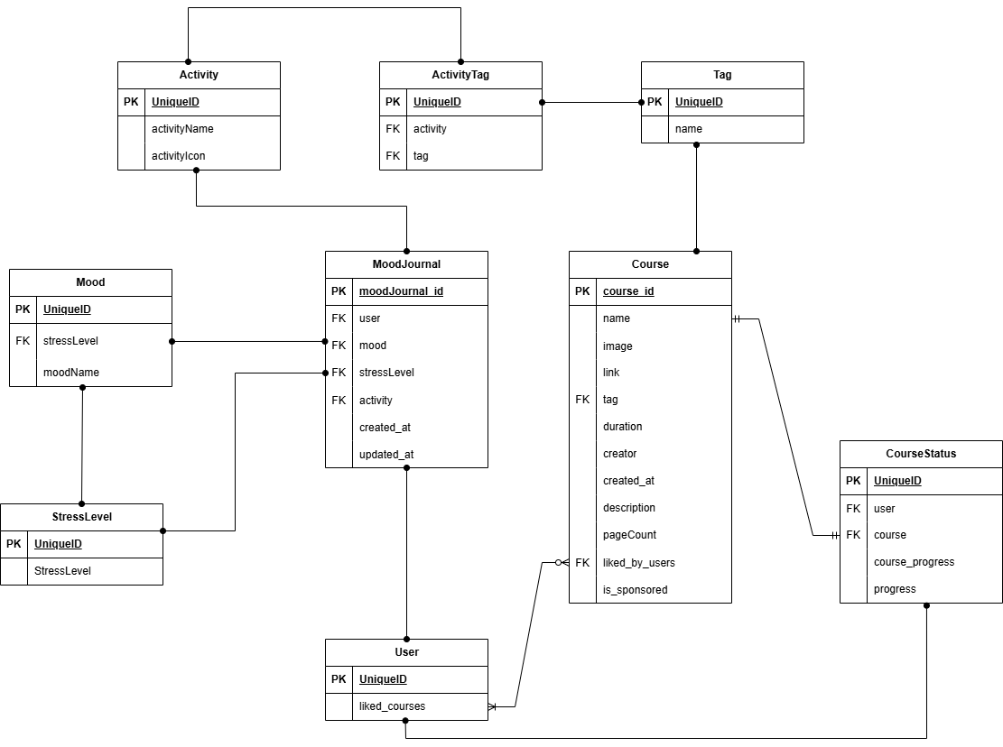
YUTH_ERD_FLOWCHART.drawio

Entity Relation Diagram

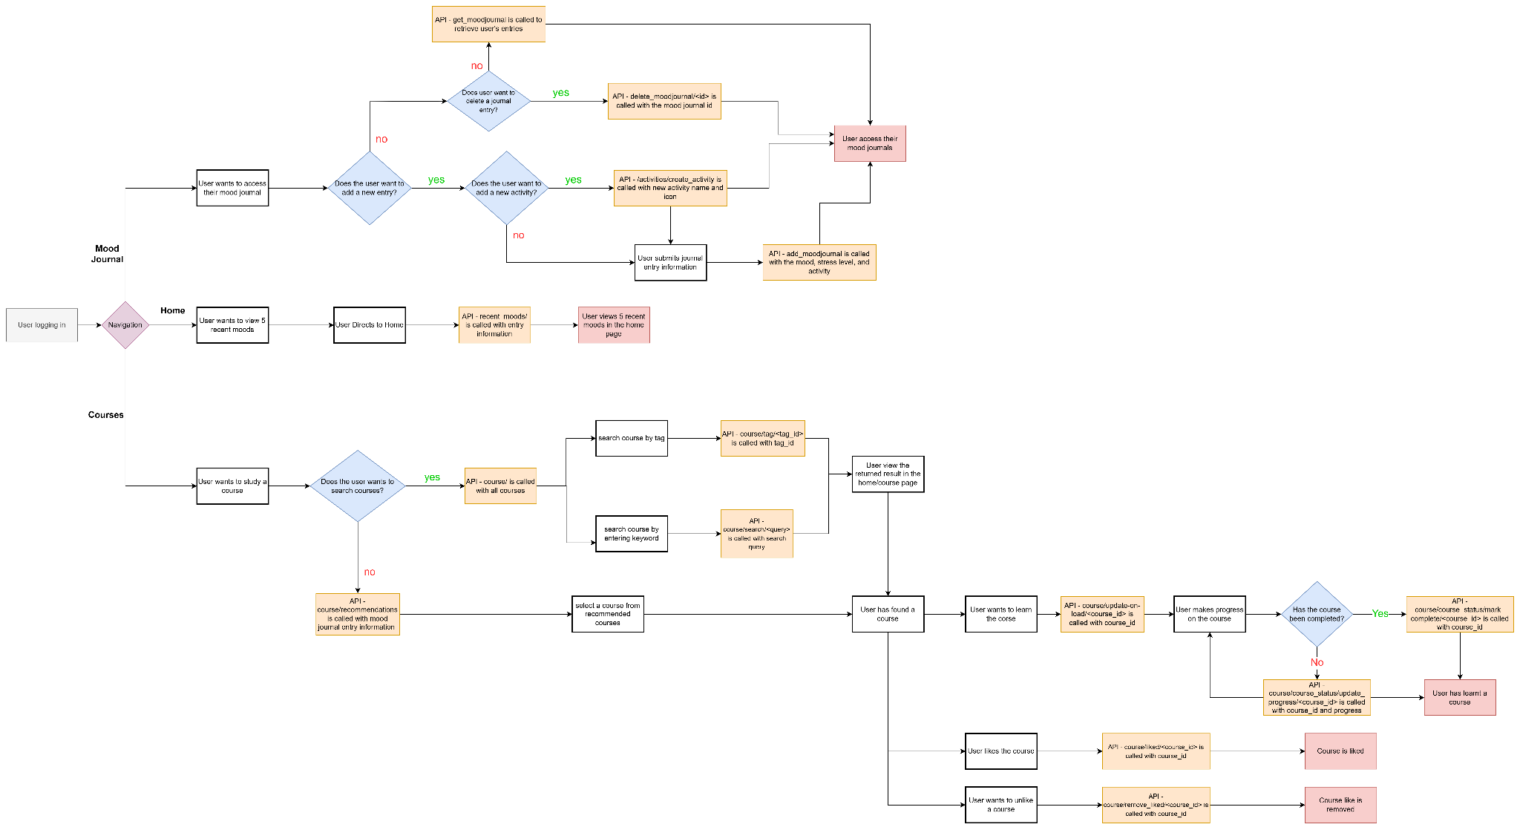
Flow Diagram

