Youth Finance Management
Section 1: Understanding Money
- What is Money?
- The Importance of Financial Management
- Needs vs. Want
Section 2: Budgeting Basics
- What is a Budget, and Why is it Important?
- The 50/30/20 Rule
- How to Create a Simple Budget
- Renting vs Buying a House
Section 3: Saving Money
- Why saving is essential
- Short-term vs. long-term savings goals
- The power of compound interest
- Where to save: Bank accounts, piggy banks, or digital wallets
Section 4: Smart Spending
- How to compare prices and make informed purchases
- Avoiding impulse buying
- Understanding sales, discounts, and hidden costs
- Credit score matter
Section 5: Introduction to Investing
- What is Investing, and Why is it Important?
- Types of Investments
- 5 Key Principles of Investing
- How to Start Investing
Section 6: Avoiding Debt and Financial Pitfalls
- The dangers of credit card debt
- How loans and interest work
- Recognizing scams and financial fraud

Section 7: Retirement 101

Section 1: Understanding Money
What is Money?
Money is a medium of exchange that allows people to trade goods and services efficiently. It holds value and can be saved, spent, or invested. Money comes in different forms, such as cash, digital currency, and bank deposits.
The Importance of Financial Management
Financial Management is understanding and using financial skills like budgeting, saving, and investing. It helps individuals make smart money decisions, avoid debt, and build wealth over time. Being financially literate gives people control over their financial future.
Needs vs. wants
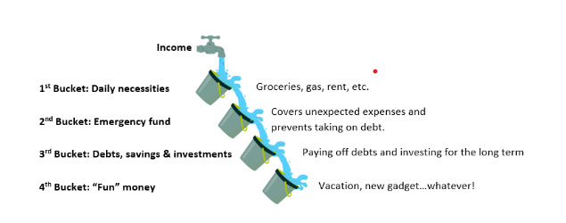

Activity: List five things you recently bought and categorize them as needs or wants. Discuss how these choices impact your finances.

Section 2: Budgeting Money
What is a Budget, and Why is it Important?
A budget is a financial plan that helps individuals manage their income and expenses effectively. It ensures that money is allocated appropriately for necessities, savings, and discretionary spending. A budget is important because it prevents overspending, helps save for future goals, and provides financial stability.
The 50/30/20 Rule
This budgeting method divides income into three categories:
- 50% for Essentials (needs like rent, food, and bills)
- 30% for Wants (entertainment, dining out, shopping)
- 20% for Savings and Debt Repayment (emergency funds, investments, or paying off loans) Following this rule ensures balanced spending while prioritizing savings.
According to a 2022 StatsCan survey, 26% of Canadians said they could not afford a sudden $500 expense . That’s roughly 10 million Canadians! The Financial Consumer Agency of Canada suggests saving the equivalent of 3 to 6 months of your regular expenses, although it very much depends on your circumstances.
https://www.ciro.ca/office-investor/investing-basics/youth-guide-finance-and-investing#borrowing-money
How to Create a Simple Budget
- Calculate Total Income - Identify all sources of money, such as a job or allowance.
- List Necessary Expenses - Track fixed costs like rent, transportation, and food.
- Allocate Money for Wants - Set a limit for non-essential expenses.
- Set Savings Goals - Decide how much to save each month and stick to it.
- Monitor and Adjust - Review the budget regularly to make improvements.
Renting vs Buying a House
If you want to evaluate each option from a financial perspective, you will need to consider, among other data points:
- home prices in your area;
- current mortgage rates;
- how much of a down payment you can afford;
- how much of a mortgage you could qualify for, and;
- rent prices in your area;
Although you should consider all of these variables to make an informed decision, it might be worth starting simple.
You (and your partner) could start by asking:
- Where do I (we) want to live?
- Do I (we) have steady income?
- Do I (we) have or want a family?
- Do I (we) want to live in a city centre, suburb or small town?
  - Would buying a home in the suburbs or rural community require one or more vehicles to get around?
 | Renting | Buying
Pro | - Property and appliance upkeep rest with the landlord  - Easier to relocate to a new neighborhood or city | - “My/Our” space  - Renovate as you wish  - Home/land are investments
Con | - Rents can increase  - Not building equity (paying someone else’s mortgage) | - Very expensive to purchase and maintain. All upkeep expenses rest with you  - More difficult and expensive to relocate
Activity: Create a sample monthly budget based on a $500 allowance or part-time job earnings.

Section 3: Saving Money
Why saving is essential
Short-term vs. long-term savings goals
The power of compound interest
Compounding simply means continuous growth. Imagine you grew 10% taller everyday. Today you would have grown by more than yesterday, and tomorrow you will grow by more than you did today. This effect can apply to your debts if you miss payments.
Where to save: Bank accounts, piggy banks, or digital wallets
Activity: Calculate how much you can save in a year if you set aside $10 per week.

Section 4: Spending Money
How to compare prices and make informed purchases
Avoiding impulse buying
Understanding sales, discounts, and hidden costs
Credit score matter
Everyone has a credit score which tells the world how reliable you are when it comes to paying back a loan on time and in full. A high score makes it easier to borrow more and for cheaper for example Cell phone plans, home utilities, credit cards, and internet all provide something upfront you promise to pay for later
How do I get a good credit score?
Step 1 is getting credit. Consider a no annual fee credit card or cell phone plan in your name (make sure it’s one you can afford).
Step 2 is pay off your bills each month, on time and in full! Making the ‘minimum’ payment or skipping a bill altogether means you will start owing interest while also lowering your credit score.
How do I check my credit score? There are two main credit bureaus in Canada which can provide you with your credit score: Equifax and TransUnion
For more information on your credit report and score basics check out the Government of Canada's resources.
Activity: Look up two similar items online and compare prices, reviews, and value for money.

Section 5: Investing Money
What is investing, and why is it important?
Different types of investments
Stocks - Buying shares of a company to own part of the business.
Bonds - Lending money to companies or governments in exchange for interest payments.
Mutual Funds - Pooling money with other investors to invest in a mix of stocks and bonds.
Real Estate - Purchasing property to rent or sell for a profit.
Cryptocurrency - Digital or virtual currencies that can be bought, sold, and traded.
Commodities - Investing in physical goods like gold, oil, or agricultural products.

5 Key Principles of Investing
- Can you afford to invest?
If you’re finding it difficult to afford the necessities (rent, groceries, etc.) investing may not be something to consider right now.
- Are you willing to diversify?
By investing in multiple different assets, industries or regions, you can reduce your overall amount of risk-taking.
- Invest for the long-term
Long-term investors (think decades) generally experience better returns as asset values typically increase over time.
- Understand risk vs. return
High risk can mean high reward – or, big losses. Curious about how risky of an investor you are? Check out our Investor Questionnaire.
- Understand your investments
Consider the 3 W’s: WHERE is your money invested? WHO is handling your investment, and WHAT are you invested in?
If you don’t understand how your investment grows, what the costs are, or the risks, you should consider something less complicated.
How to Start Investing
  - Self-Managed Account: The investor makes all investment decisions, researches the market, and executes trades independently. This option provides more control but requires financial knowledge and time commitment.
  - Professionally Managed Account: A financial expert, such as a portfolio manager, handles investments on behalf of the investor. This option is ideal for those who prefer guidance and professional expertise but usually comes with management fee
Activity: Research a popular company’s stock performance over the past year and discuss whether it would be a good investment.

Section 6: Avoiding Debt and Financial Pitfalls
The dangers of credit card debt
The graph shows how quickly debt can spiral out of control if you miss payments. After 10 years, a $5,000 loan would cost
- over $6,000 as a student loan (2.3% annual interest);
- nearly $10,000 as a car loan (7% annual interest);
- over $30,000 as a credit card loan (19.99% annual interest).
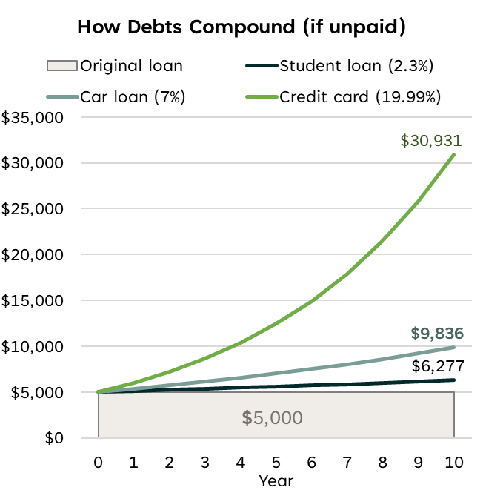
https://www.ciro.ca/office-investor/investing-basics/youth-guide-finance-and-investing#borrowing-money
How loans and interest work
Recognizing scams and financial fraud
Easy as 1-2-3: Here are the basic ways to protect yourself:
- Keep your online activities secure.
- Stay skeptical and learn how to spot the red flags of fraud.
- When you do invest, confirm the person or firm you’re working with is registered with CIRO.
If you suspect fraud or believe you may be a victim of a scam:
- Stop sending money;
- Collect your thoughts and document your experience;
- Report the fraud, and;
- Secure your information and accounts.
Find out what to Do If You’re a Victim of Fraud.
Activity: Discuss common financial scams targeting young people and how to avoid them.

Section 7: Retirement 101
Many Canadians will rely on income from 3 sources to be comfortable in retirement:
  - Workplace pension;
  - Private savings, and;
  - Social security.
The Office of the Investor’s 2024 Investor Survey revealed retirement as the most cited investment goal.
Find out if your workplace offers a pension plan and, if so, contribute.
Save early, save often.
https://www.ciro.ca/office-investor/investing-basics/youth-guide-finance-and-investing#borrowing-money

Final Activity: Write down three financial goals you want to achieve in the next year and how you plan to reach them.

