Constant Contact Outbound

Integration Guide

Setup Instructions

These directions will allow an agency to associate a client’s Constant Contact account and set up access to push contact data.

Step 1: Client Creates a Constant Contact Developer App and Generate Client Id and Client Secret (To be performed by Client team)

Step 1.1 : Creating Constant Contact App

- Visit Constant Contact Developers (https://developer.constantcontact.com/) and go to the My Application tab (or https://developer.constantcontact.com/login/index.html) and log in with your credentials.

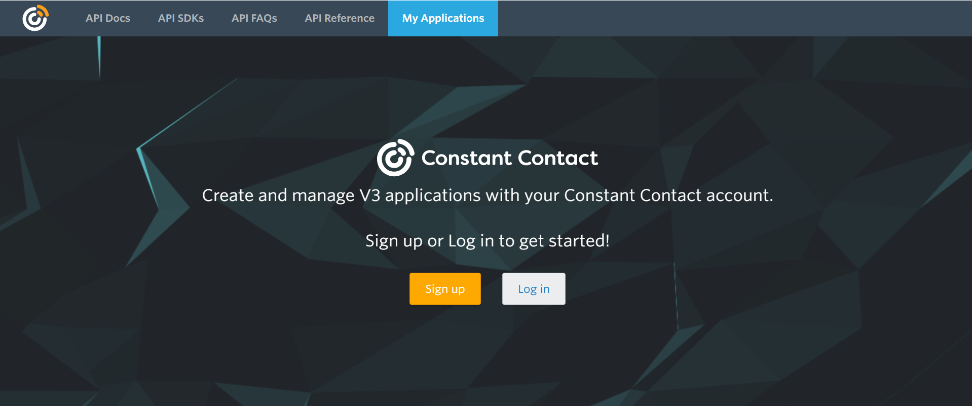

- Click on New Application.
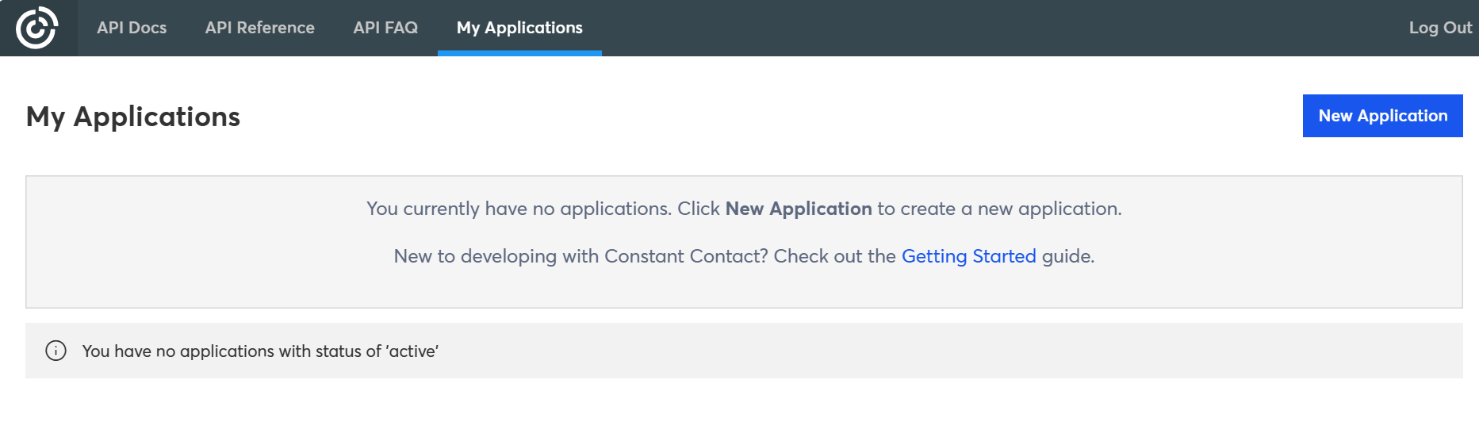
- In New Application window provide an App Name and keep all other options as it is then click Create.
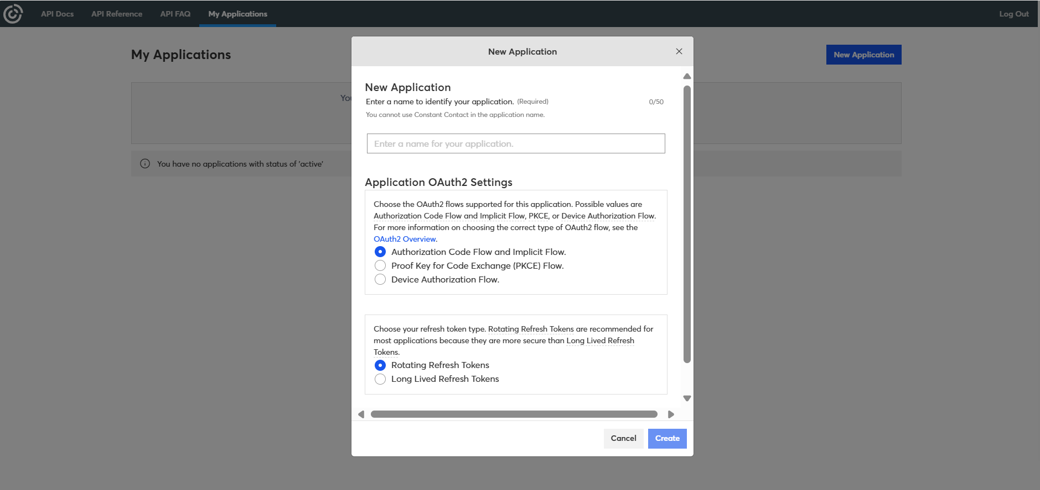

Step 2.2: Generate Client Id and Client Secret

- Click on Edit to get Client Id and generate Client Secret
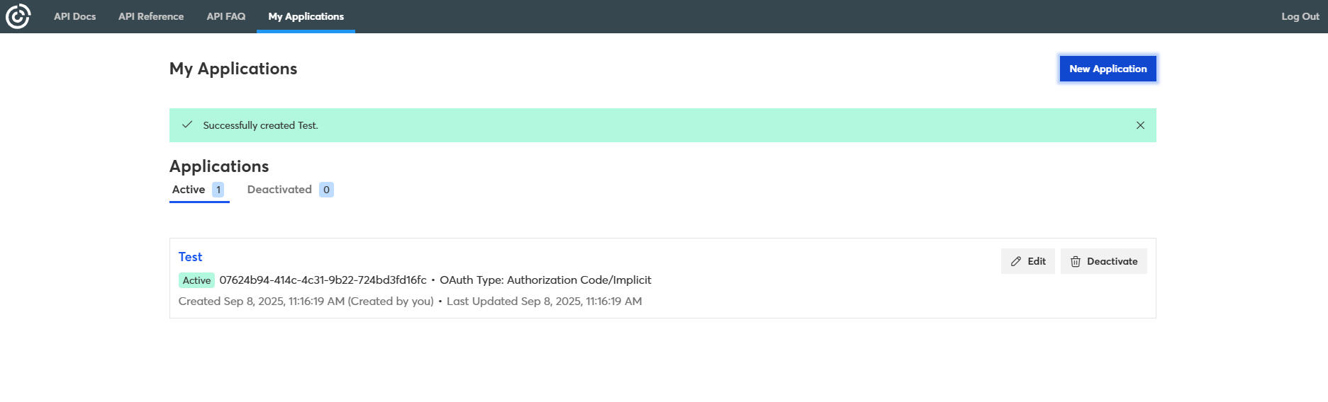
- Copy the Client Id as shown in the below image and share securely with the bettrData team.
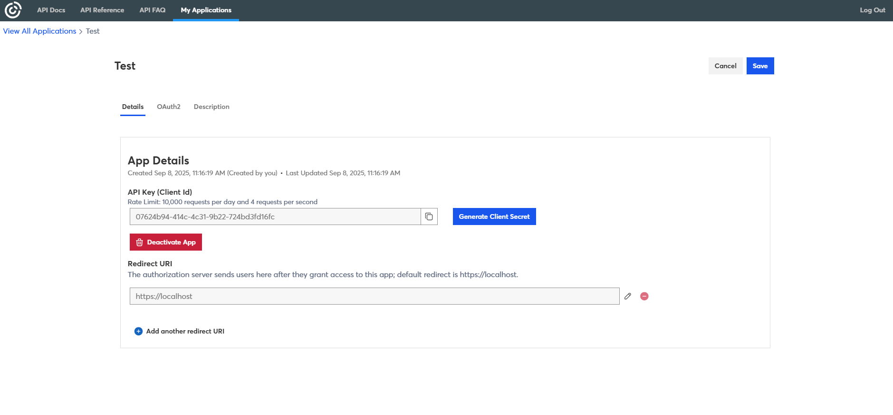
- Now click on Generate Client Secret which is just in-front of client id to get Client Secret. After this copy the Client Secret from the App secret window as shown in below image and click on Close. Share Client Secret securely with the bettrData team.

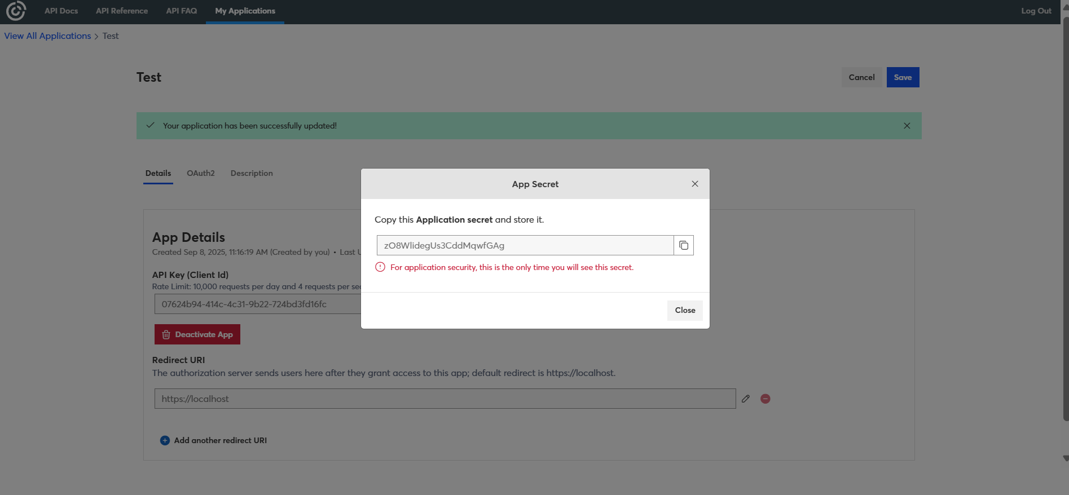

- Now enter https://oauth2.prismatic.io/callback this URL in the Redirect URI field shown in the below image and click on Save.

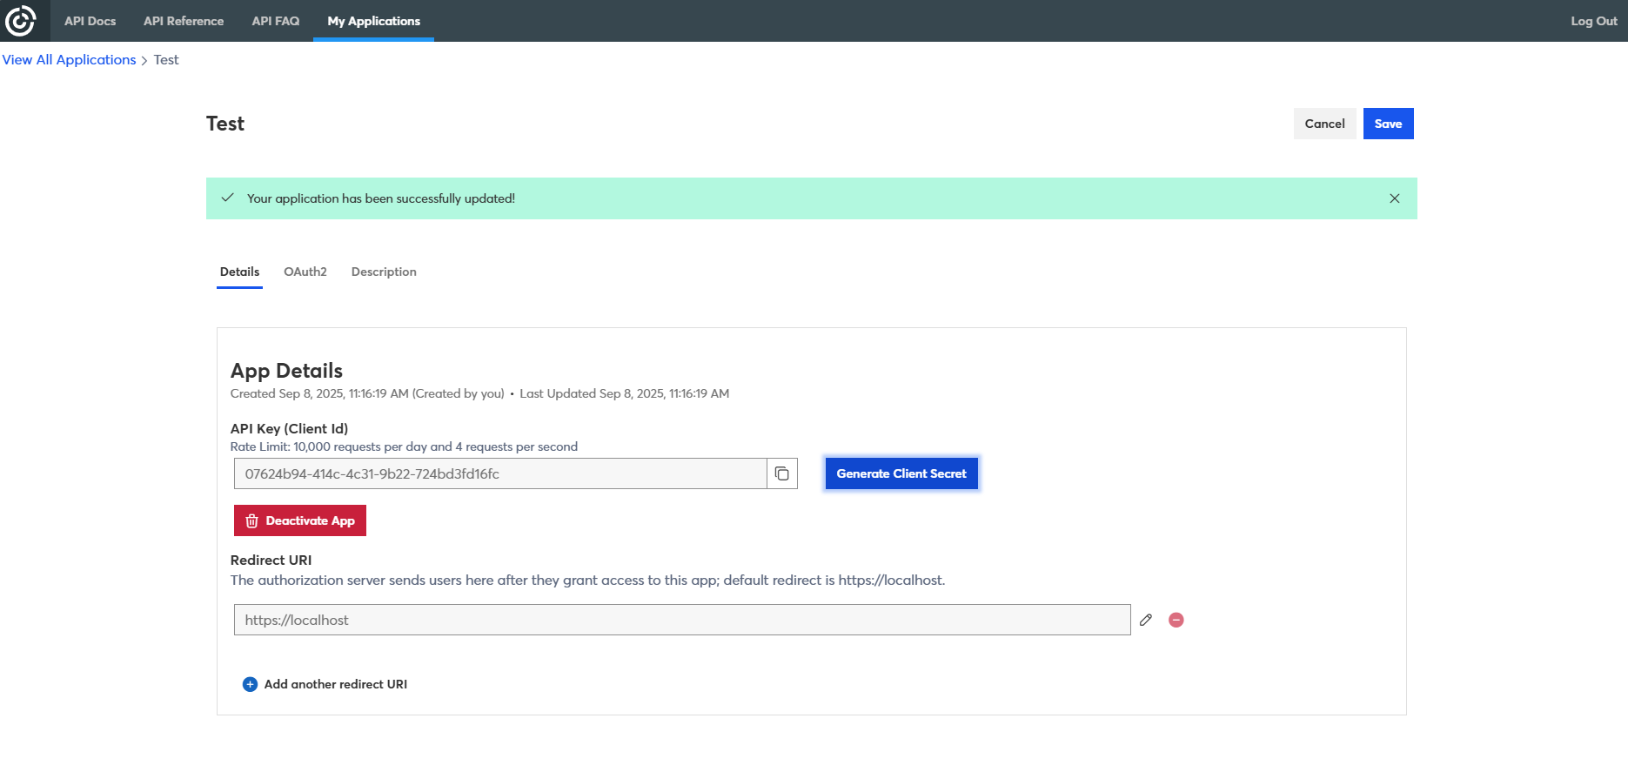

Step 2 : Creating Contact List (If not present or Want to create new list)
- Go to Home(Dashboard) page in your Constant Contact account or https://app.constantcontact.com/home#/ use this link to go there.

- Now click on Audience section and then click on Lists as shown in the below image.
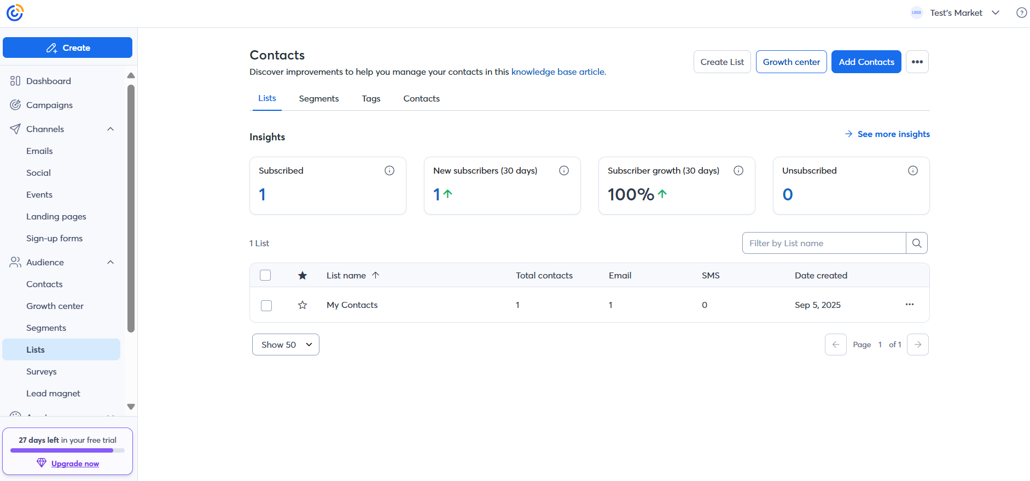
- Now click on the Create List button as shown in the below image.
- Enter the name of the list and click on Save.
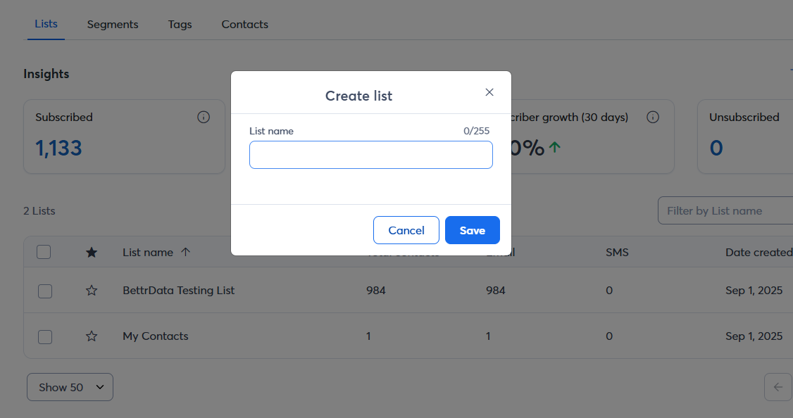

Step 3 : sharing Contact List Id to Bettrdata team.

- Go to Home(Dashboard) page in your Constant Contact account or https://app.constantcontact.com/home#/ use this link to go there.

- Now click on Audience section and then click on Lists as shown in the below image.
- Now click on the name of the specific Contact List you want the Id for.
- After clicking, check the URL in your browser as shown in the below image.
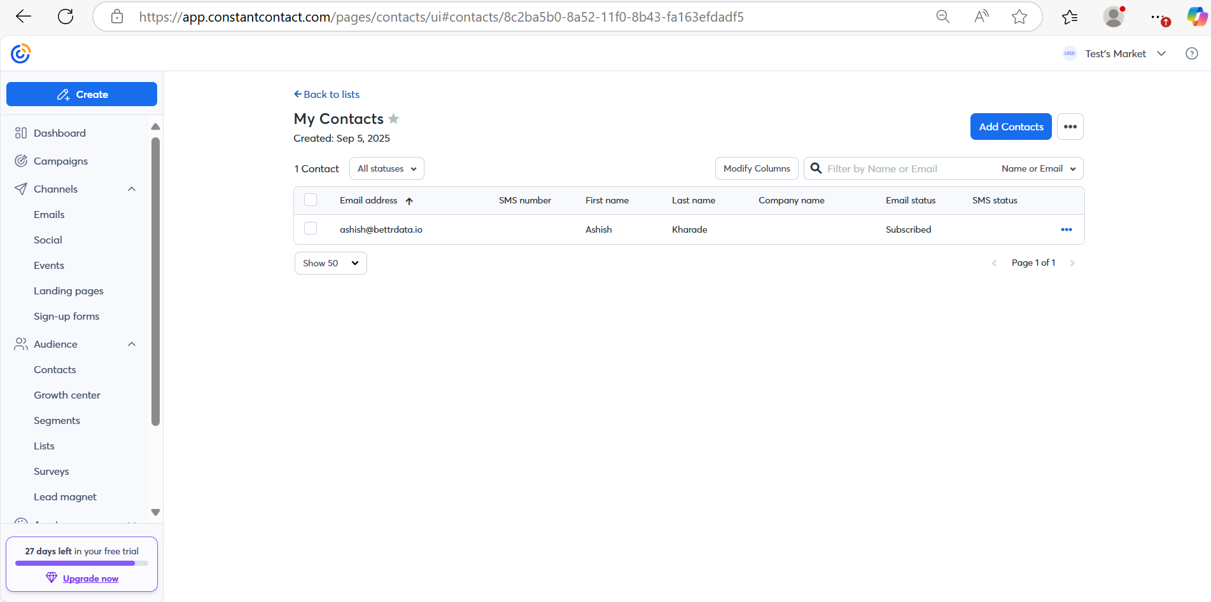
- Share this id securely to bettrData team.

Constant Contact Outbound Configuration

- Log into the Bettrdata app.
2. Go to Data Sources > Integrations Marketplace.
3. Click on the Constant Contact Outbound.
4. Click on configure
5. On the first page add in detail
1. Connections (Name):Constant Contact Outbound (Client name).
6. Copy the trigger url of Parent template workflow to invoke the workflow.
7. Click Next. There will Constant Contact Connection in that enter the Client Id and Client Secret and Click on Connect.
8. Sign in with the constant contact account associated with the Bettrdata Integration App. After this a page will appear with the message “Authorization completed successfully!”
9. Click Next. New page appears called Configuration.
1.In the client id text box, enter in the Client id. This is done by clicking on the text box and a drop down of clients will be displayed. Choose the relevant client. Click on Next.
10. Add a map of data to fit the csv data to fit the required Constant Contact customer data file format. There is no need of hashing required to any field.

"email": "email"
"first_name": "first_name"
"last_name": "last_name"
"job_title": "job_title"
"company_name": "company_name"
"birthday_month": "birthday_month"
"birthday_day": "birthday_day"
"mobile_phone": "mobile_phone"
"phone": "phone"
"home_phone": "home_phone"
"work_phone": "work_phone"
"street": "street"
"street2": "street2"
"city": "city"
"state": "state"
"zip": "zip"
"country": "country"
"home_street": "home_street"
"home_street2": "home_street2"
"home_city": "home_city"
"home_state": "home_state"
"home_country": "home_country"
"sms_number": "sms_number"
"sms_consent_date": "sms_consent_date"

- We need to pass “folder” and “listId” in the trigger payload.

Bettrdata Convert Logic

Once the data is transformed in Better data, we need to put the data into S3 into a particular format and then call the Prismatic api to consume the data file.

S3 Persistence

File Format Signature:

s3://bettrdata-prismatic-dev- 01/<<instance_id>>/<<client_id>>/<<random_id>>/<<data_list_id>>_<<file.id>>.csv

Where:

- instance_id: The name of the bettrdata instance, such as dev01 or c4
- client_id: The bettrdata client id, that is the “Data Owner” id in the new UI or the Client id in the old UI
- random_id: A random id to put the data into without duplicates
- data_list_id: The id to the Contact List
- file.id: The file id we use in Bettrdata

Prismatic Logic

With the integration set up in prismatic, it will find the data in the location to the point:

- Bettrdata passes the random id to prismatic api
- Prismatic processes s3://bettrdata-prismatic-dev-01/<<instance_id>>/<<client_id>>/<<random id>> under it, and splits into list of files for Google
      - Get data list id from file name
      - Passes in a post the random id, uses the file is as the random id

{
"folder": "a5e26790-a111-4b2b-af59-29e0c33fa62n"
}

