Facebook Audience Outbound

Integration Guide

Setup Instructions

These directions should allow agency to associate client’s ad account and set up Facebook access

Step 1: Request Client’s Facebook Ad Account Access from Bettrdata Facebook Ad Manager Account and Connect It (To be performed by Bettrdata team)

  - Access Facebook Business Manager
- Go to Facebook Business Manager https://business.facebook.com/
- Log in with your Facebook account credentials If you don't have a Business Manager account, create one by clicking "Create Account".

  - Add Client’s Facebook Ad Account

    - In Business Manager, navigate to Business Settings (gear icon)
    - Click on Accounts in the left sidebar
    - Select Ad Accounts Check ad account is listed.
    - If not, Click Add and choose:

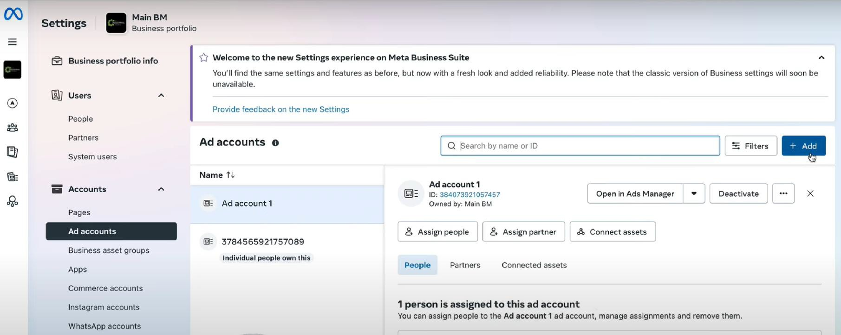

      - Add an Ad Account if you own by clicking on Claim an existing ad account.
      - If you want to add client’s ad account then click on Request Access to an Ad Account
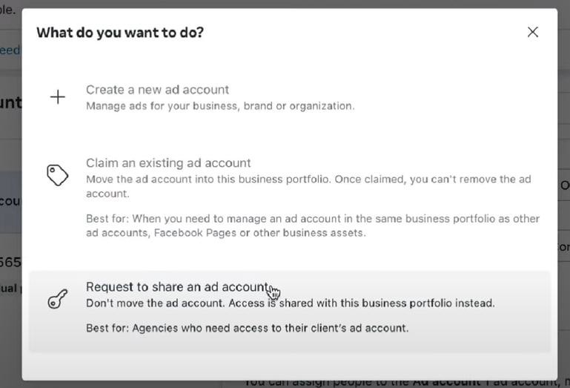

- Enter the client’s Ad Account ID in Ad account ID field (format: 123456789012345) and click on Next.

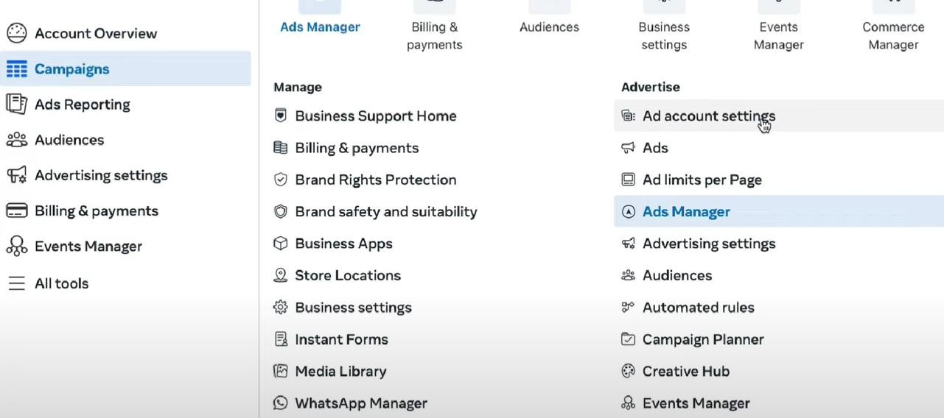
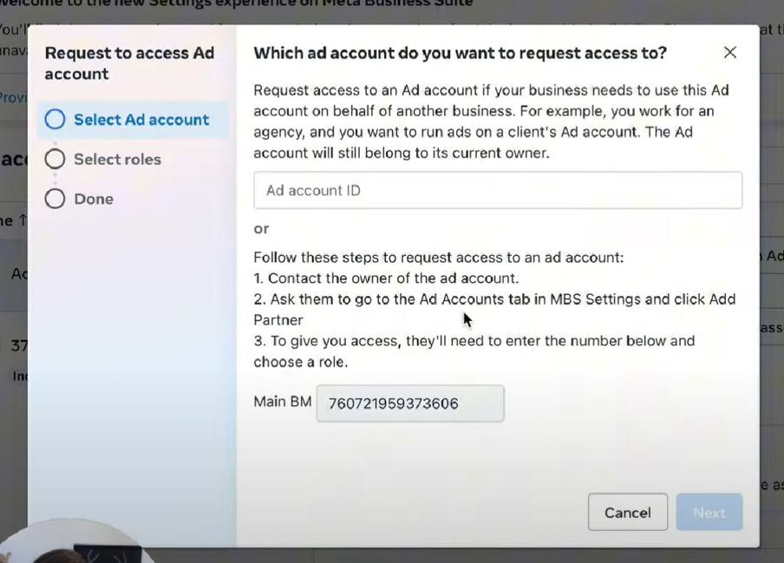

- Now under “select roles” section. As an agency owner you can either request a partial access just to manage campaigns or you can go ahead and ask for admin access which is full control. Select your role and click confirm and hit done.
- Now client got the request from your side for access now ask client to approve the request.

Client Approving Bettrdata Facbook Ad Manager Link Request (To be performed by Client’s team)
  - To approve request ask client to go their campaigns section in left sidebar and click on Ad account settings as shown in below image:

  - Now scroll down and check for banner named Ad account roles and click on

Respond to request.
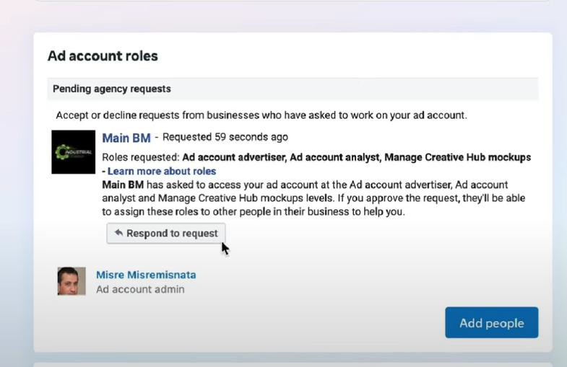
  - Now click Give access to my Ad account.
    - Now agency have access to the client’s ad account.

Step 2: Create a Facebook App of Bettrdata Facebook Ad manger account(If not already created) & Generate Access Token (To be performed by Bettrdata team)

Step 2.1 : Creating Facebok App
- Visit Facebook Developers (https://developers.facebook.com/) and log in with your credentials that have access to Facebook Ads.
- Navigate to My Apps and click Create App.

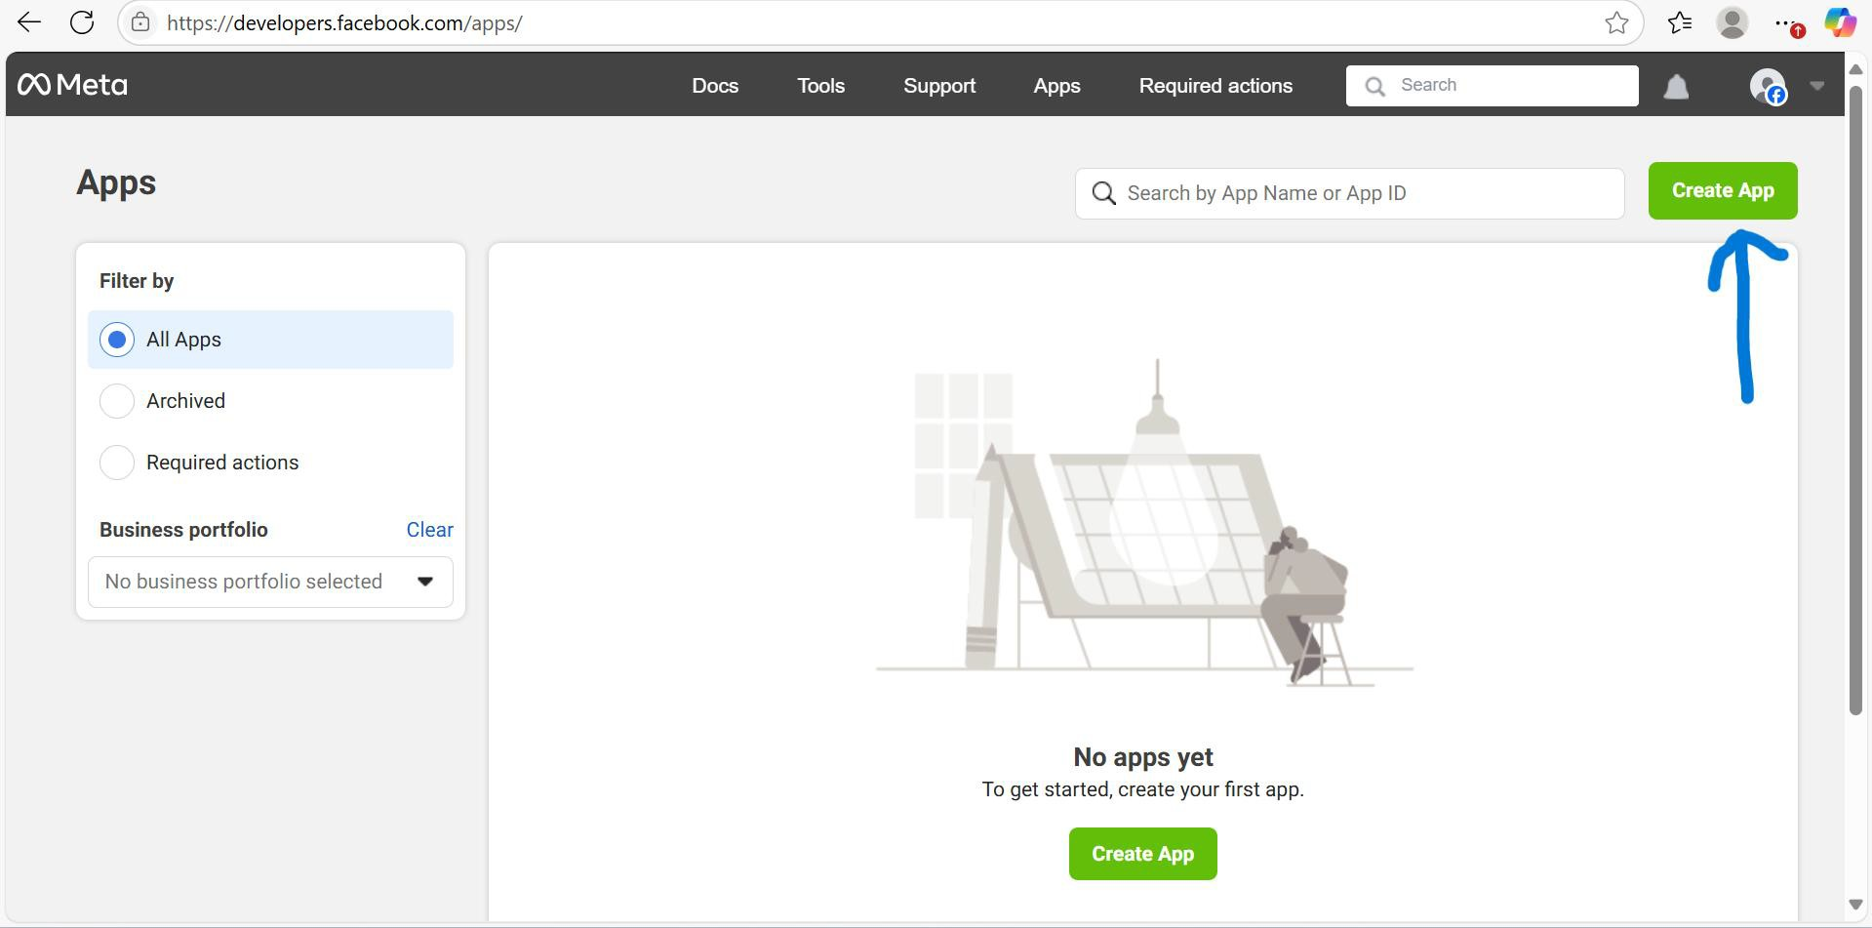
- In App details provide an App Name and an Email Address for contact purposes, then click Next.
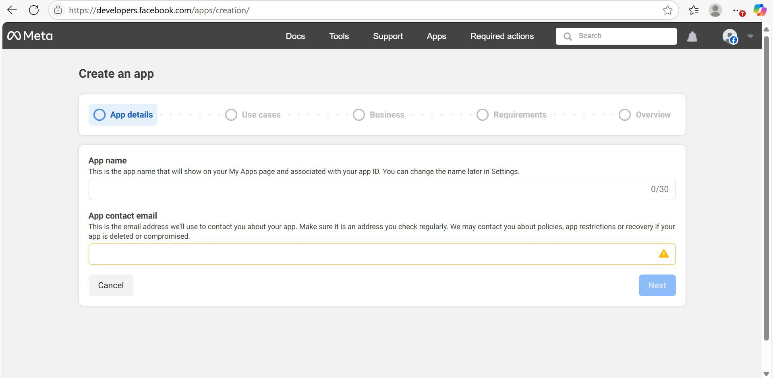
- In the Use Cases section, select Other and click Next.
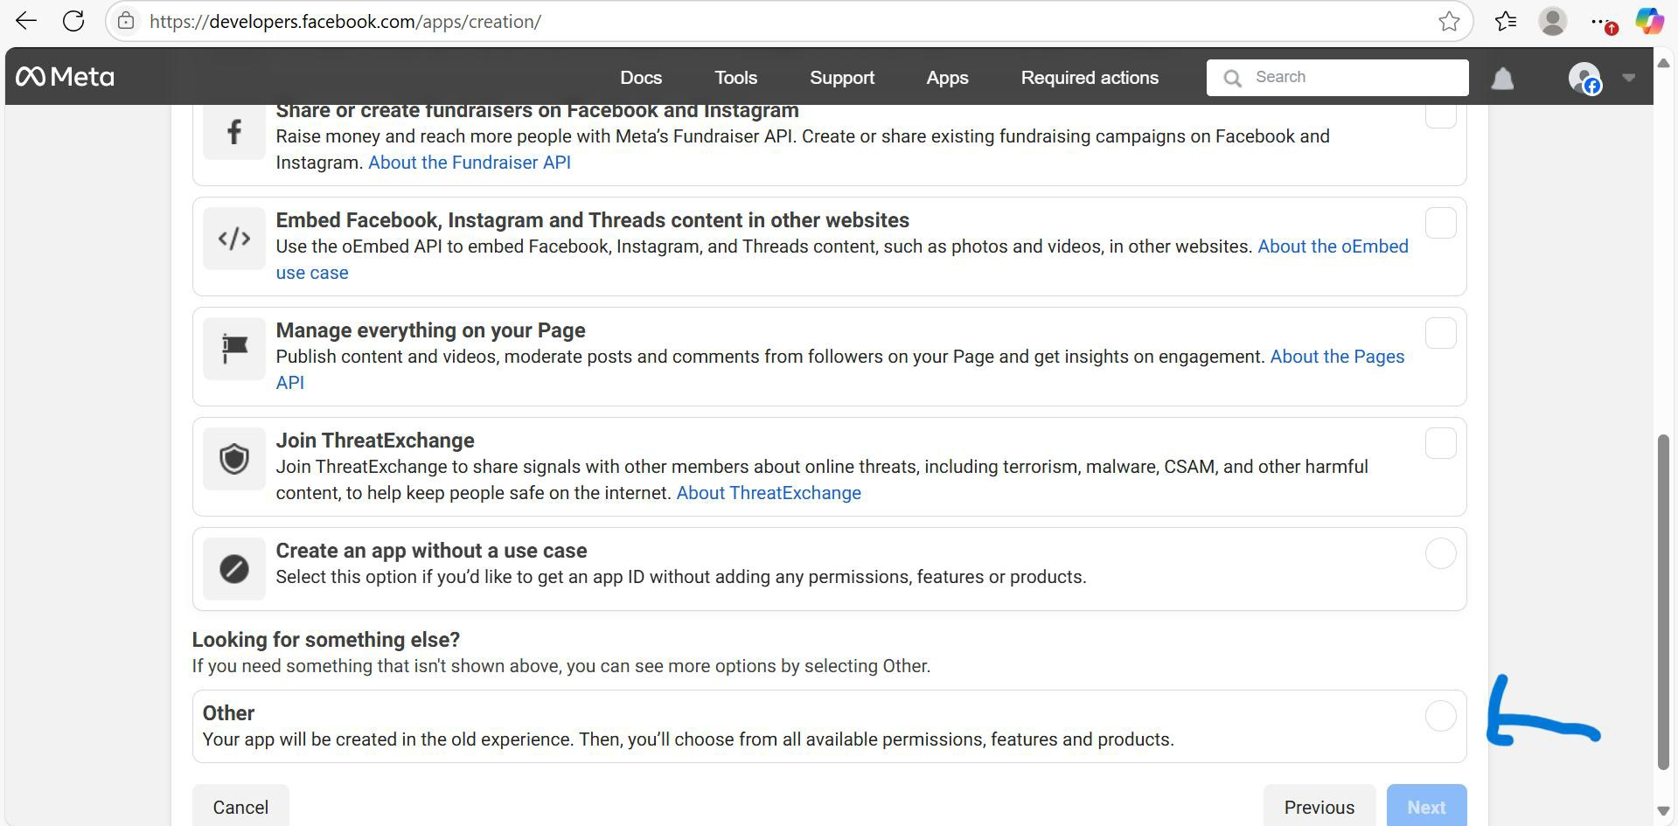
- In the App Type selection, choose Business and click Next.

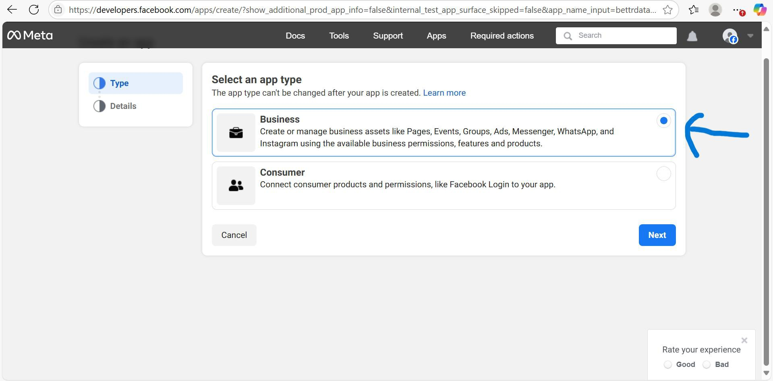
- On next page which is details page there will be a field form fill details if required and click on Create app.

Step 2.2: Generate Access Token
- Click Add Product which is present in left sidebar.
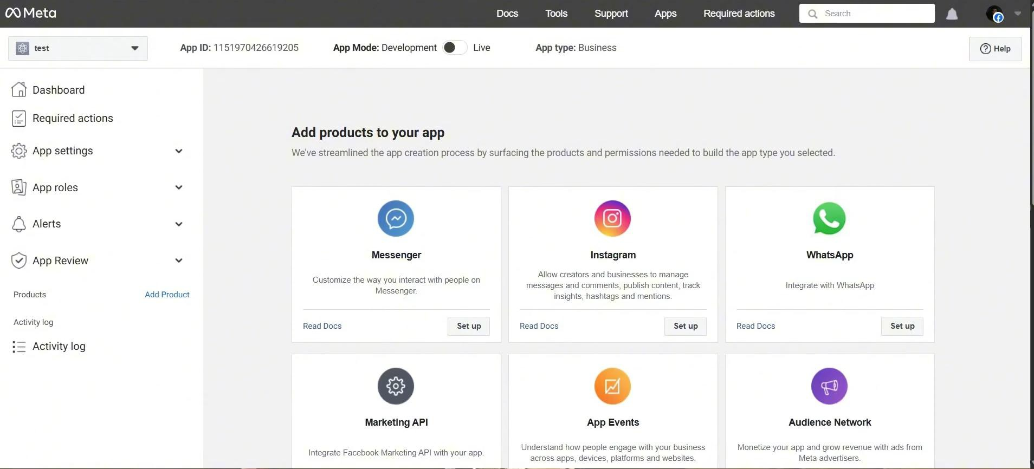

- After clicking, in the Add Products section, click Set Up under Marketing API
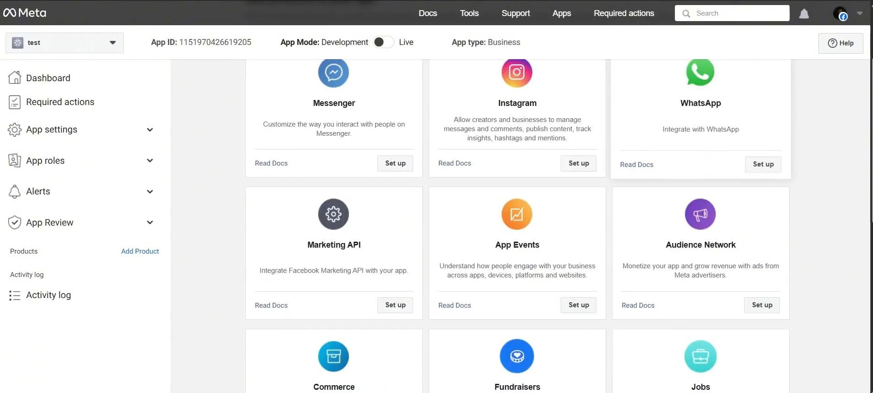

- In the Marketing API which is in left sidebar Click on Tools, and in that section select
ads_management, ads_read, read_insights and click Get Token which is present in right.
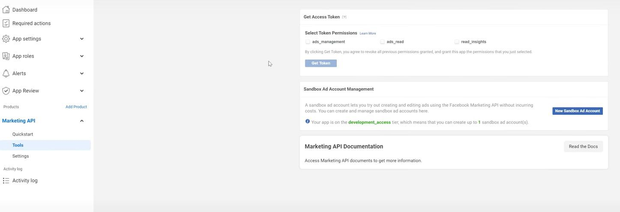

- Capture that generated token and share securely with bettrData team.
- Capture the Ad Account Id which is shared by client and share securely with bettrData team.

Step 3 : Creating Audience List and sharing Audience Id to Bettrdata team.

Step 3.1: Accept Custom Audiences Terms

- Visit the Custom Audiences Terms (https://www.facebook.com/ads/manage/customaudiences/tos.php) page.
- Accept the terms to enable custom audience creation.

Step 3.2: Find the Audience Id

For Custom Audiences in Meta Ads Manager (or Business Manager):

Go to Audiences
  - Navigate to Meta Audiences (or go via Meta Business Suite > Audiences).

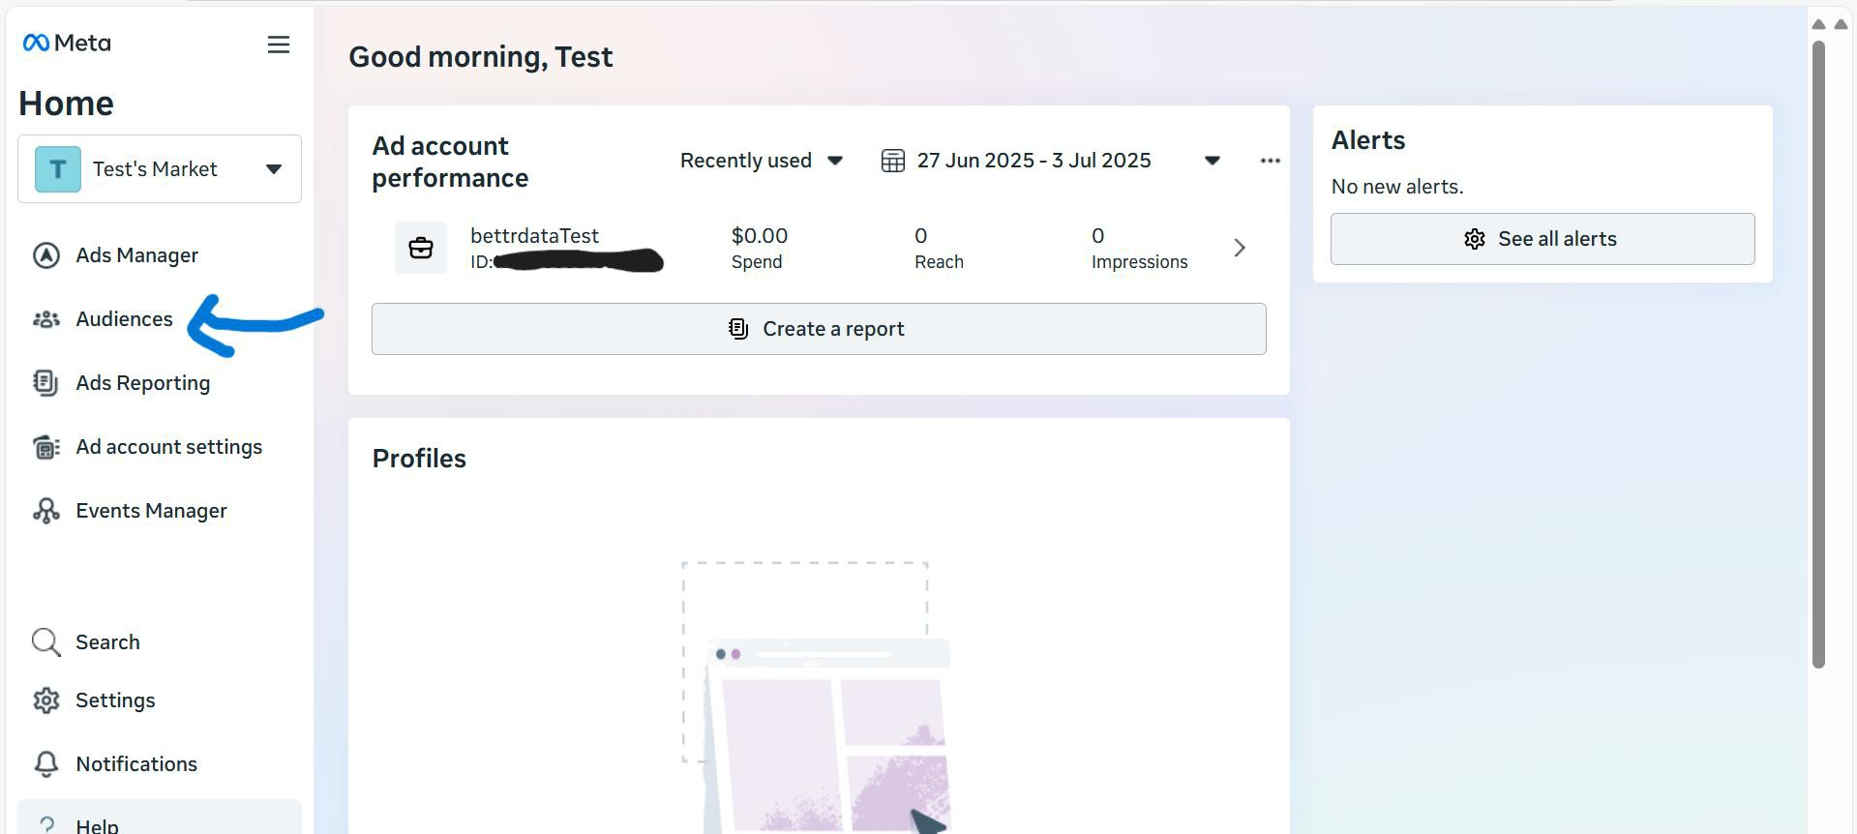

Locate Your Audience

    - If already present you’ll see a list of all your saved, custom, and lookalike audiences.
    - If Not found the list then create any audience you want.

Now click the Audience Name

      - Click on the name of the specific Custom Audience list (or any audience) you want the ID for.
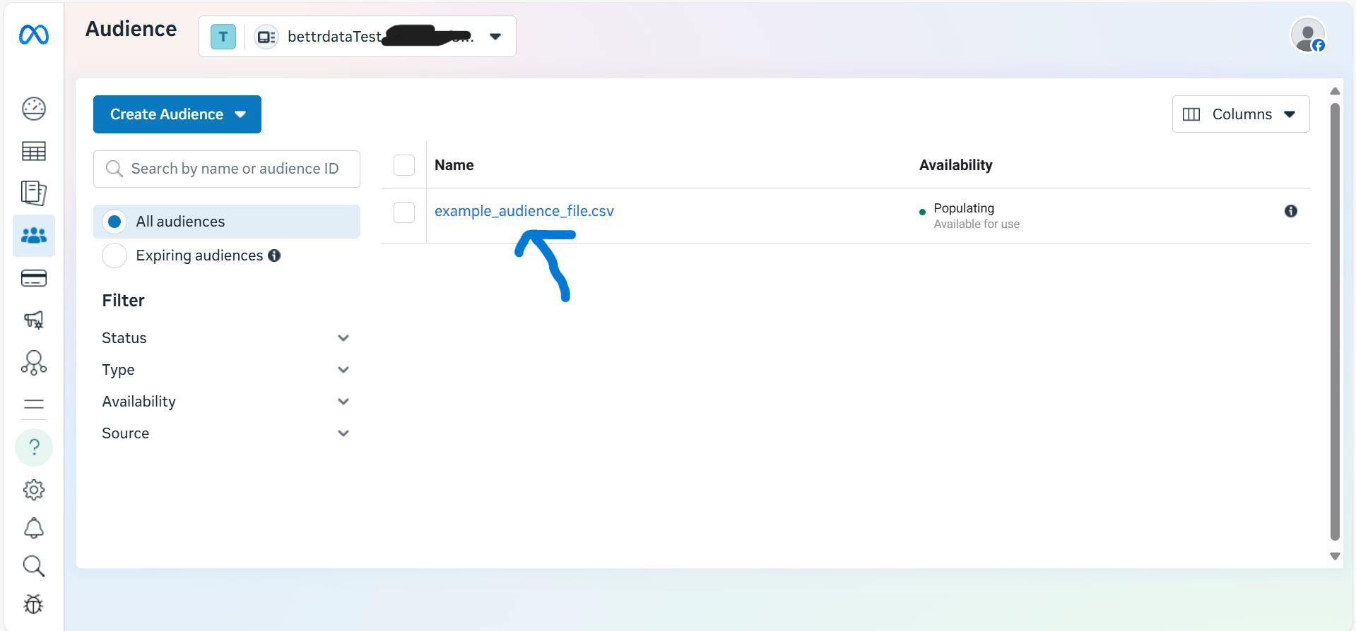

Get the Audience ID

      - After clicking, check the URL in your browser. It will look something like this:

https://business.facebook.com/adsmanager/audiences/manage/?act=1234567890&aud ience_id=0987654321

- The part after audience_id= is your Audience List ID.

If in case you don’t found in the URL then Just click Columns field and select Audience Id from list and you will get Audience id as shown in Image
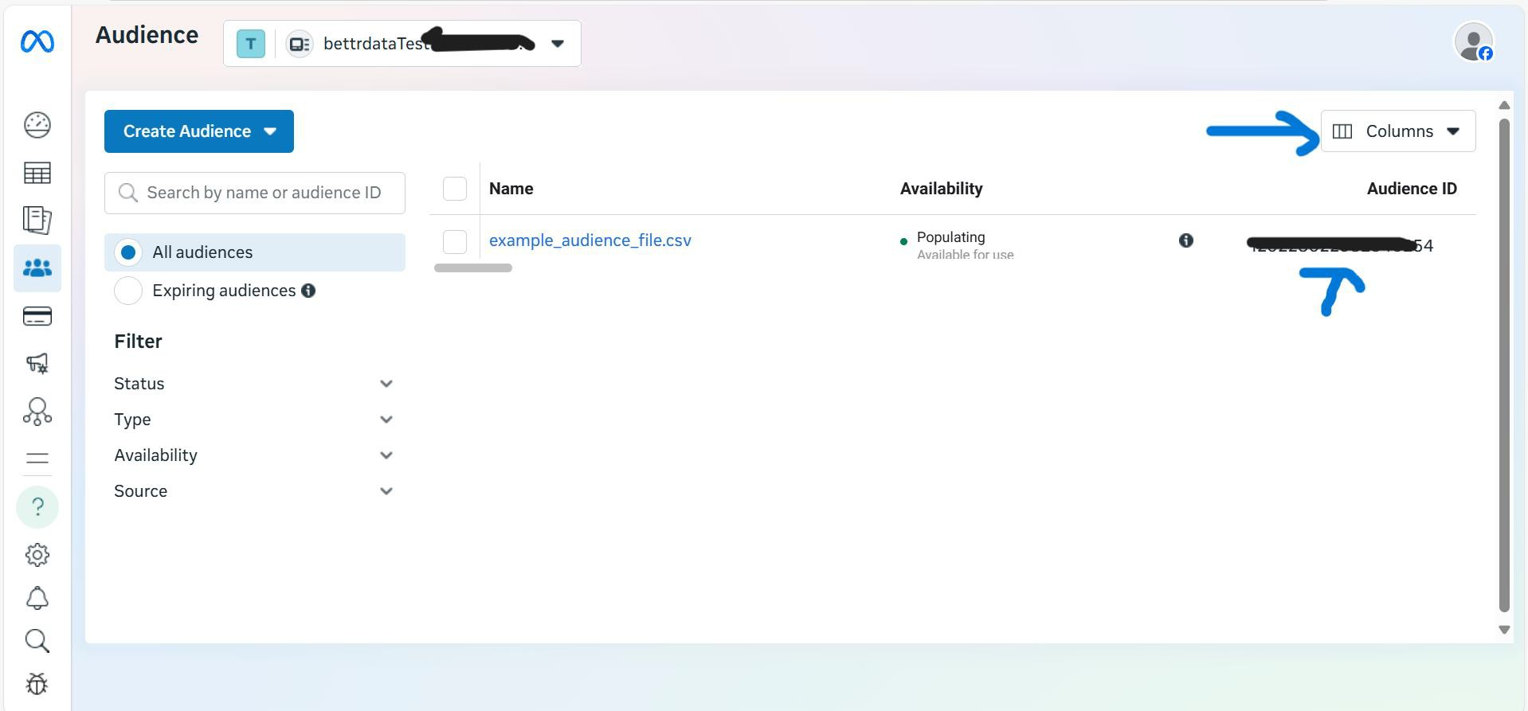

    - Share these securely to bettrData team.

Facebook Audience Outbound Configuration
- Log into the Bettrdata app
- Go to Data Sources > Integrations Marketplace.
- Click on the Facebook Audience Outbound
- Click on configure
- On the first page add in detail
  - Connections (Name): Facebook Audience Outbound (Client name)
- Copy the trigger url of Parent template workflow to invoke the workflow.
- Click Next. There will be a field called Access Token in that enter the Access token provided by the client.
- click Next. New page appears
- In the client id text box, enter in the Client id. This is done by clicking on the text box and a drop down of clients will be displayed. Choose the relevant client. Click on Next
- In the next page, enter the AccountId. This is the id of the client facebook account, with no hyphens included.
- Add a map of data to fit the csv data to fit the required Facebook Ads customer data file format. The csv headers are

Bettrdata Convert Logic

Once the data is transformed in Better data, we need to put the data into S3 into a particular format and then call the Prismatic api to consume the data file

S3 Persistence
File Format Signature:

- s3://bettrdata-prismatic-dev- 01/<<instance_id>>/<<client_id>>/<<random_id>>/<<data_list_id>>_<<file.id>>.csv

Where:
- instance_id: The name of the bettrdata instance, such as dev01 or c4
- client_id: The bettrdata client id, that is the “Data Owner” id in the new UI or the Client id in the old UI
- random_id: A random id to put the data into without duplicates
- data_list_id: The id to the Facebook Audience
- file.id: The file id we use in Bettrdata

Prismatic Logic
With the integration set up in prismatic, it will find the data in the location to the point:

- Bettrdata passes the random id to prismatic api
- Prismatic processes s3://bettrdata-prismatic-dev- 01/<<instance_id>>/<<client_id>>/<<random id>> under it, and splits into list of files for Facebook

  - Get data list id from file name
  - Passes in a post the random id, uses the file is as the random id

{

"folder": "a5e26790-a111-4b2b-af59-29e0c33fa63a"

}

