Hubspot Outbound Integration Guide

Setup Instructions

These directions will allow an agency to associate a client’s Hubspot account and set up access to push contact data.

Step 1: Client Creates a Hubspot Developer App and Generate Client Id and Client Secret (To be performed by Client team. This is optional step. In case we need to change the Hubspot app and reconfigure the workflow.)

Step 1.1 : Creating Hubspot App

- Visit Hubspot Developers (https://developers.hubspot.com/) and log in with your credentials or click on create developer account to go into your account. Now click on Legacy Apps which is situated on the left side bar.

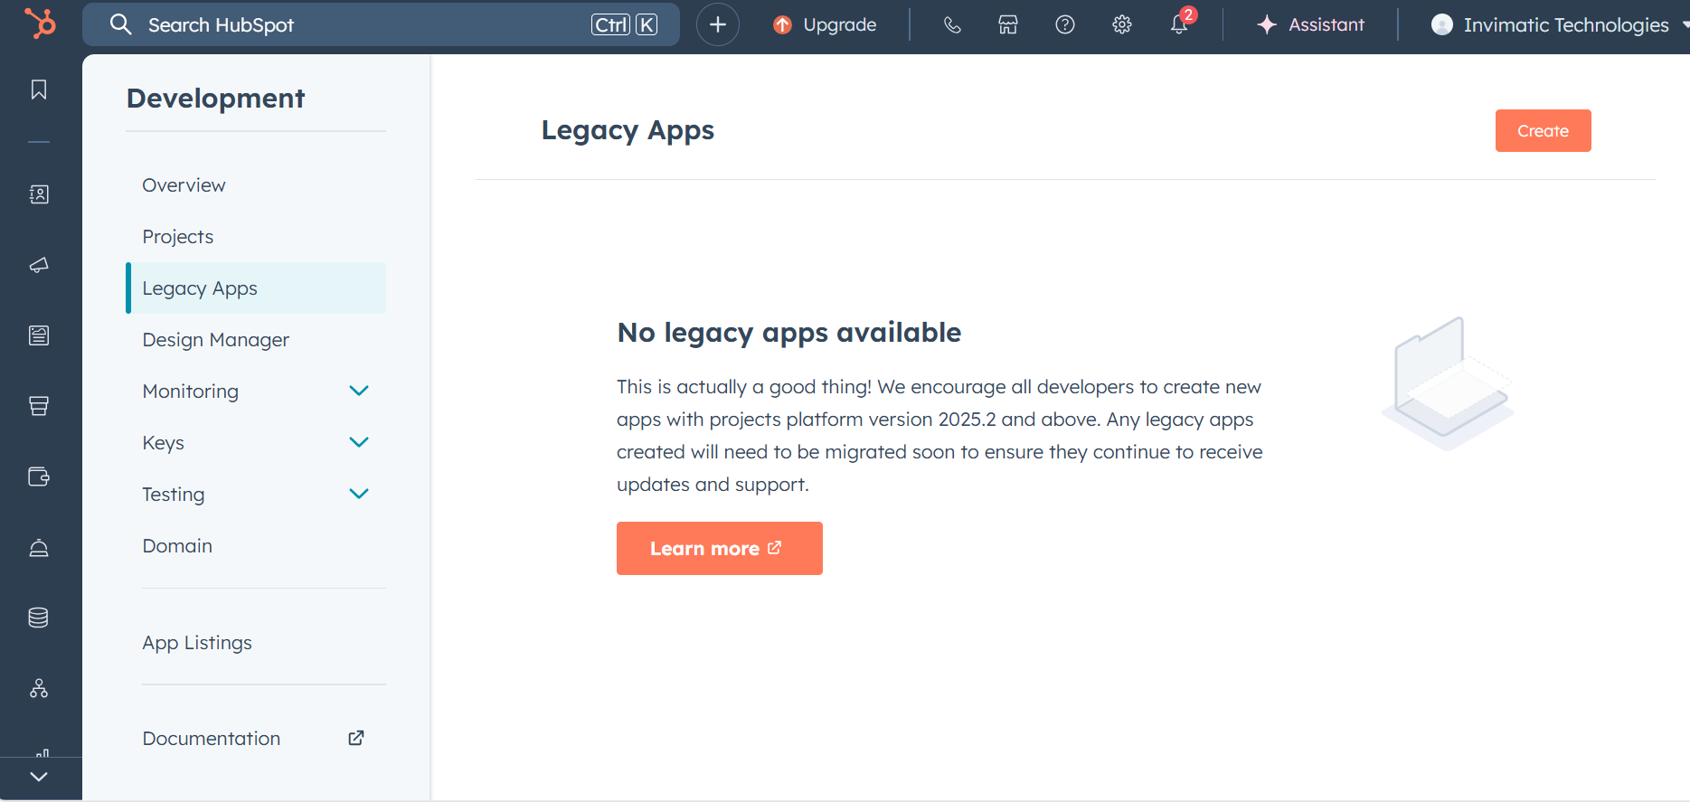

- Click on Create. After this click on public to create public app.
- Now fill all the details present on App Info tab shown in below image. After this follow Step 2.2 (below step).
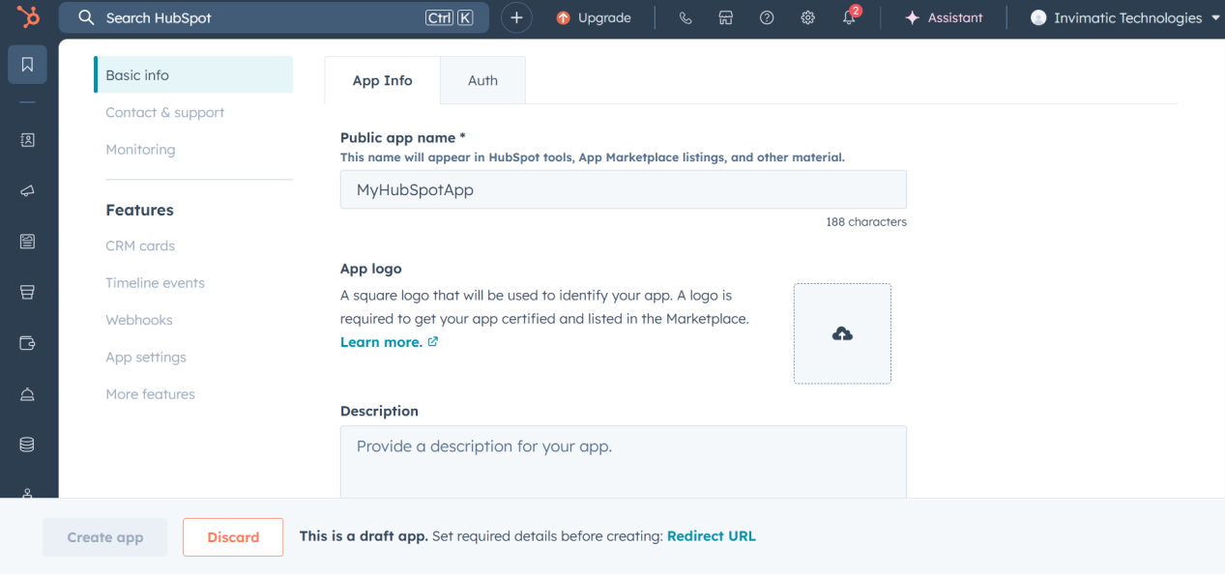

Step 2.2: Generate Client Id and Client Secret

- Click on Auth tab to get Client Id and generate Client Secret
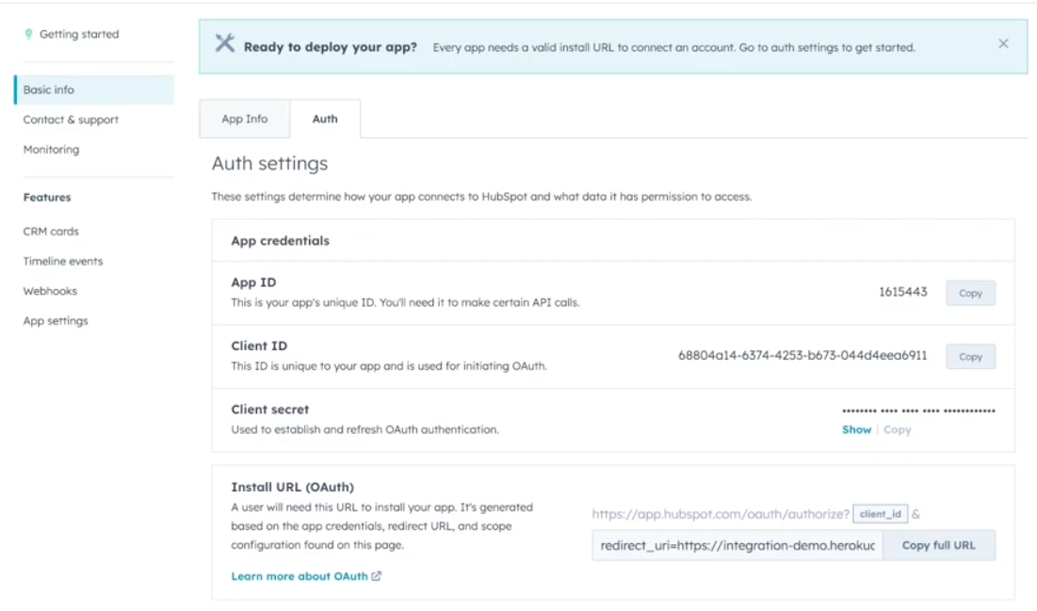
- Enter the redirect url (https://oauth2.prismatic.io/callback) and click on Add new scope to add required scopes.
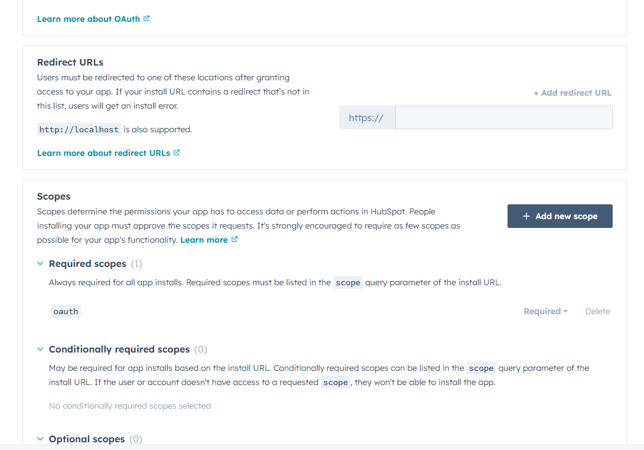
- Now select required scopes from the list.

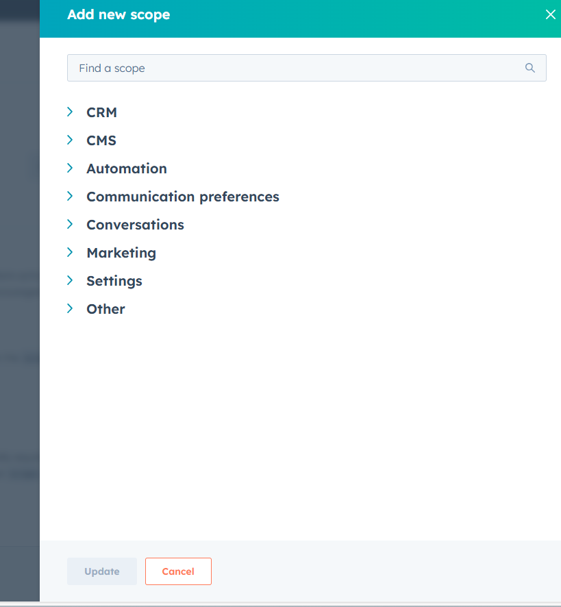

- Now after filling all the details click on Create app button.
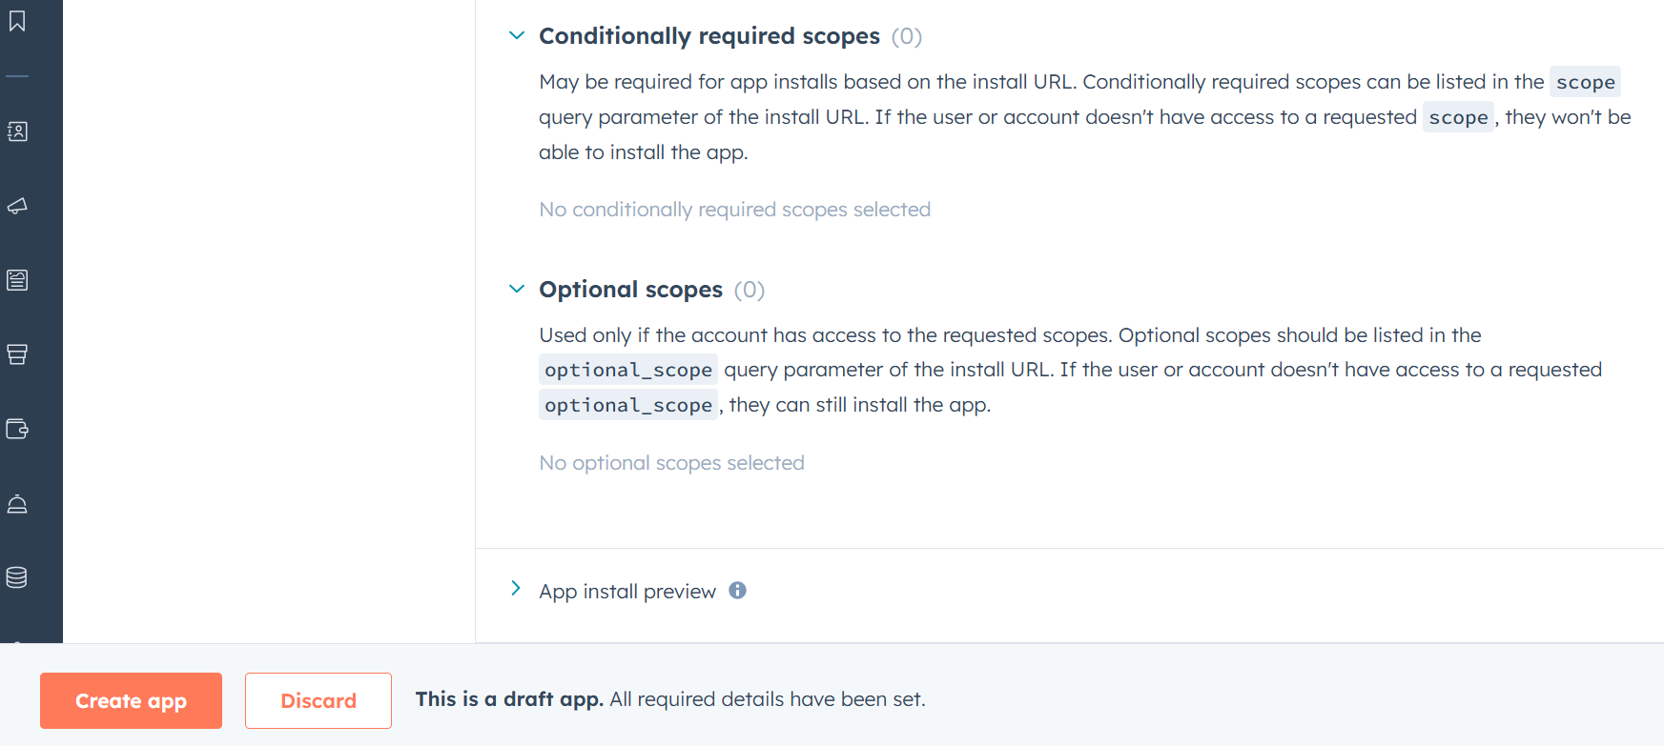
- Now after creating app Again click on Auth tab and copy the App ID, Client ID, Client secret. Provide these to the bettrData team.

Hubspot Outbound Configuration

- Log into the Bettrdata app.
2. Go to Data Sources > Integrations Marketplace.
3. Click on the Hubspot Outbound.
4. Click on configure
5. On the first page add in detail
1. Connections (Name): Hubspot Outbound (Client name).
6. Copy the trigger url of Parent template workflow to invoke the workflow.
7. Click Next. There will Hubspot Connection Click on Connect.
8. Sign in with the Hubspot account. After this a page will appear with the message “Authorization completed successfully!”
9. Click Next. New page appears called Configuration.
1.In the client id text box, enter in the Client id. This is done by clicking on the text box and a drop down of clients will be displayed. Choose the relevant client. Click on Next.
2. Enter Flow Life and Batch size.

10. Click on next and Add a map of data to fit the csv data to fit the required Constant Contact customer data file format. There is no need of hashing required to any field.

{
"First Name": "firstname",
"Last Name": "lastname",
"Email": "email",
"PhoneNumber": "phone",
"MobilePhone": "mobilephone",
"Company": "company",
"JobTitle": "jobtitle",
"LifecycleStage": "lifecyclestage",
"Fax": "fax",
"StreetAddress": "address",
"City": "city",
"State": "state",
"Zip": "zip",
"Country": "country"
}

- We need to pass “folder” in the trigger payload.

Bettrdata Convert Logic

Once the data is transformed in Better data, we need to put the data into S3 into a particular format and then call the Prismatic api to consume the data file.

S3 Persistence

File Format Signature:

s3://bettrdata-prismatic-dev- 01/<<instance_id>>/<<client_id>>/<<random_id>>/<<file.id>>.csv

Where:

- instance_id: The name of the bettrdata instance, such as dev01 or c4
- client_id: The bettrdata client id, that is the “Data Owner” id in the new UI or the Client id in the old UI
- random_id: A random id to put the data into without duplicates
- file.id: The file id we use in Bettrdata

Prismatic Logic

With the integration set up in prismatic, it will find the data in the location to the point:

- Bettrdata passes the random id to prismatic api
- Prismatic processes s3://bettrdata-prismatic-dev-01/<<instance_id>>/<<client_id>>/<<random id>> under it, and splits into list of files for Hubspot
      - Get data list id from file name
      - Passes in a post the random id, uses the file is as the random id

{
"folder": "a5e26790-a111-4b2b-af59-29e0c33fa62n"
}

