
Analysis of external Generative AI usage in European Parliament

DG ITEC
Directorate-General for Information Technologies and Cybersecurity

Table of Contents
Table of Contents 2
Executive Summary 3
Purpose of the report 4
Analysis of GenAI usage 5
Total data usage 5
Number of EP users 7
Usage by Organisational Unit 8
Most used AI services 9
Number of services used 10
Conclusion 11

Executive Summary
On the request of European Parliament’s LSO, EP-CERT created a report regarding external Generative AI use from the European Parliament’s infrastructure. The report will be latter on enriched with the data about internal Generative AI use, as well as the use of AI from European Commission.
The analysed period is from May 2025 to January 2026.
The analysis shows the following:
- The traffic between public Generative AI services and the European Parliament continued to increase, going from 140 GB in May 2025 to 435GB in January 2026.
- The EP daily (workday), on average, downloads 25 GB of data and uploads 10 GB of data to Generative AI services. This number is rising and in January, there was 30 GB of downloads and 19GB of uploads daily.
- The approximated number of EP users accessing the Generative AI services on a daily basis is approximately 2000, with a slight increase during the observer period. The takeaway is that, on average, the same amount of users is using Generative AI services, but their use is getting heavier.
- The usage distribution by the Organisational Unit show that most of the use comes from MEP’s/APA’s at 38.5%, followed by DG-ITEC at 20.8%, and DG-COMM at third place with 7.4% of total usage.
- The usage breakdown by AI Service shows that the most popular public Generative Ai service is Open AI, representing 78% of all public GenAI usage from EP
- The usage breakdown also shows that, as of January 2026, EP users on average access 850 different Generative AI services per month, which represents a 29% increase from May 2025.

Purpose of the report
This report is created by EP-CERT at the request of the European Parliament LSO for the purpose of tracking the usage trends of generative AI tools from the European Parliament’s infrastructure. The main objective is to measure adoption of the internal AI tools and the tools provided by other EUIBA’s (most notably European Commission) against the use of public AI services.
This report concerns only the usage of public Generative AI services, and will be enriched with the usage of EP’s in house Generative AI tools as well as Generative AI tools provided by the European Commission, as soon as EP-CERT gets access to the relevant data needed for the analysis.

Analysis of Generative AI usage
The analysis of external Generative AI use is based on Splunk reverse proxy logs. The analysed period was from the beginning of May 2025 to the end of January 2026, since the last report covered the period until end of May 2025.

Total data usage
When looking on a monthly basis for the observed period, the rising trend in Generative AI usage is visible. As stated in the previous report, in May 2025 140 GB of data was uploaded to Generative AI services, while in January 2026 the amount increased to 435 GB.
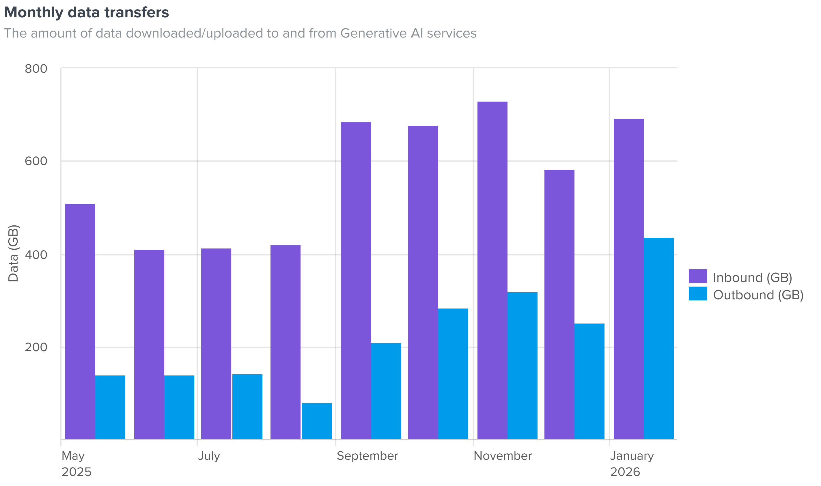

The more detailed daily analysis shows predictable weekly usage patterns as well as a drop during the Office Closing Days. When we exclude weekends, the average daily data transfer for the whole observed period is 25 GB in downloads and 10 GB in uploads, and that average is rising. In January, the average daily data transfer is 30 GB in downloads and 19 GB in uploads.
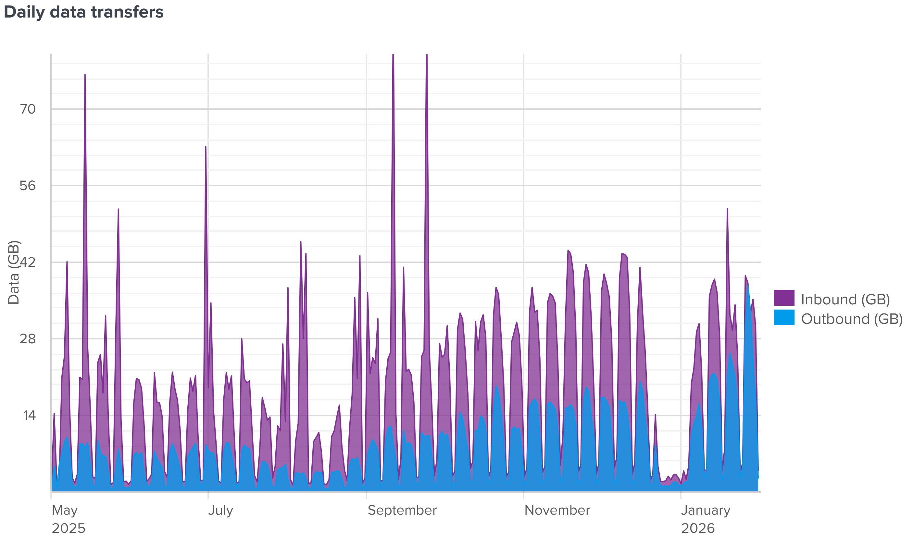

Number of EP users
The methodology to evaluate the number of daily users that use Generative AI services was improved in regards to the last report and is done by identifying the unique IP addresses that access such domains on any given day and then corelating the IPs with DNS lookup logs to get the hostnames of the devices that access those services. The average number of EP users accessing Generative AI services during a workday is around 2000.
The number of users using generative AI services remained relatively stable with a slight increase during the observed period, with the expected fluctuations during the holiday periods. This suggests that the number of people in EP that use Generative AI is not massively increasing, but that their usage is getting heavier as the time goes on.
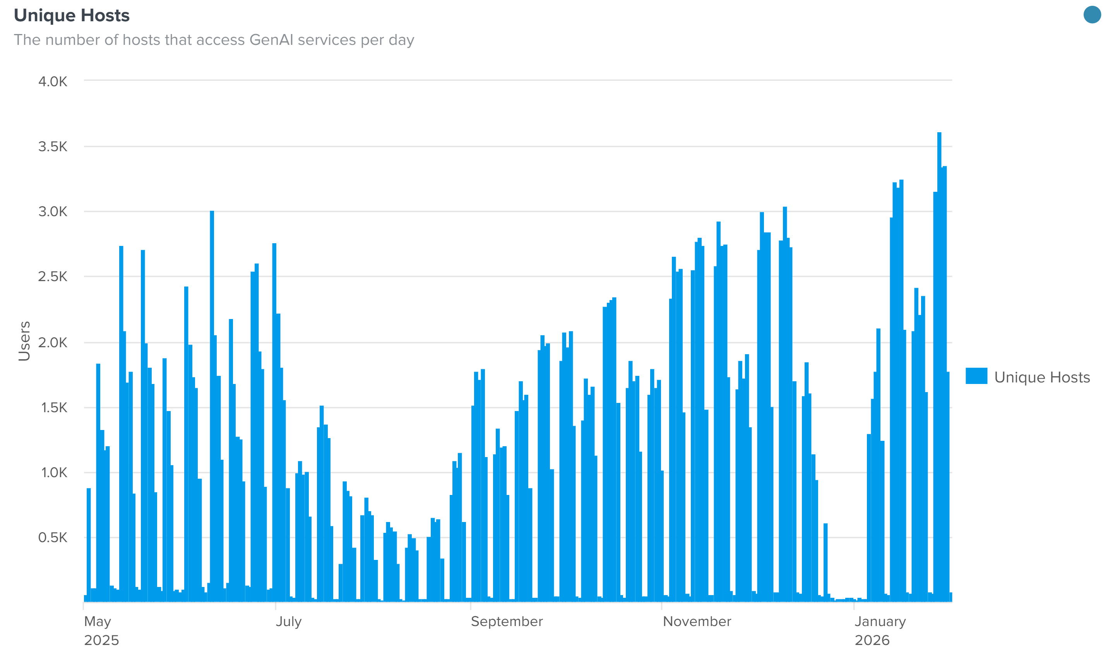

Usage by Organisational Unit
Correlating the proxy logs with DNS lookup logs, EP-CERT managed to create a list of external Generative AI usage split by the Organisational Units (DG’s and MEP’s). This was done by collecting the hostnames of the devices accessing the Generative AI services and grouping them by the prefix that corresponds to the top level Organizational unit of the EP.
The statistics show that MEPs/APAs are the biggest users of GenAI services at 38.5%, followed by DG-ITEC at 20.8%, and DG-COMM at third place with 7.4% of total usage.
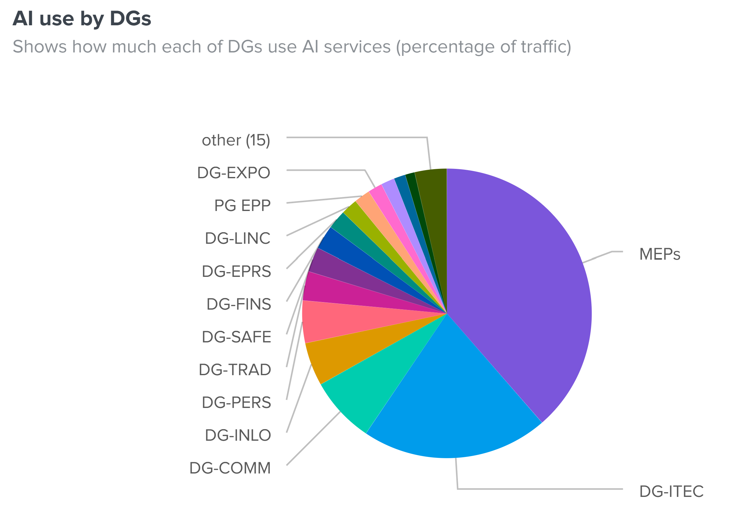

Most used AI services
Looking at the amount of data flowing from the parliament to the specific Generative AI services, we can see that the majority of traffic is going to OpenAI endpoints, in total encompassing 78% of all uploaded data to Generative AI services. This is a drop of 10% in relation to the previous report.
Other service of interest is hf.co, coming in 2nd place with 9% usage, which corresponds to Hugging Face, open-source AI platform (“GitHub of AI”). This service hosts numerous models and allows interacting with them, which means that we cannot determine the exact models used on the platform.
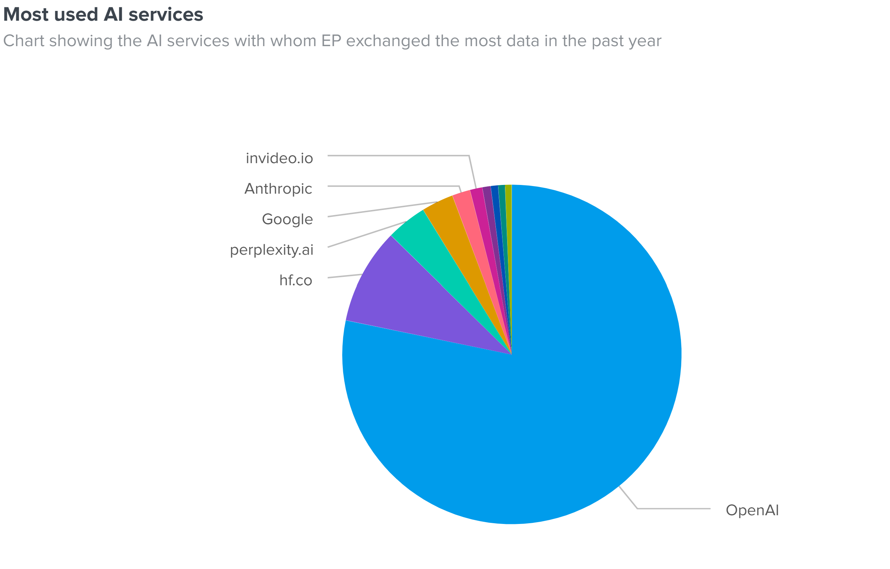

Number of services used
Lastly, the report analyses the number of unique Generative AI services used. EP-CERT approximated this by counting the monthly unique domains accessed from the EP infrastructure.
The number of unique Generative AI services remained steady for the period from May 2025 to September 2025, hovering around 660 services, and from September 2025 to end of January 2026 it increased by approximately 29% to 850 services per month. This shows that users are increasingly interacting with less known services that might not have a well defined stance towards data protection and privacy.
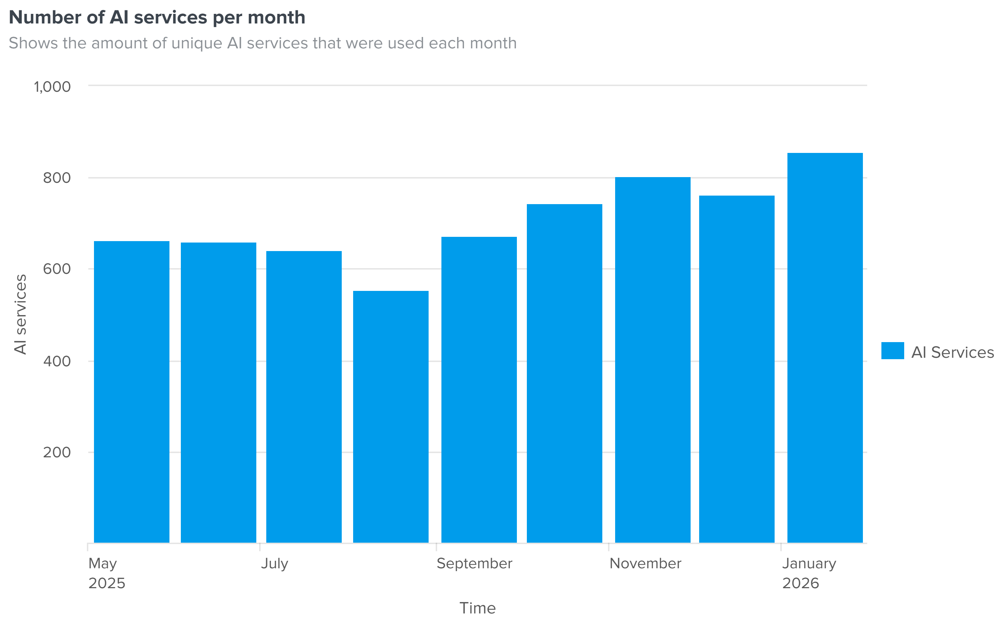

Conclusion
The analysis shows a continued trend increase in usage of public Generative AI services since the last report, and the increasing parliament reliance on AI. Considering the number of daily IPs accessing such services, it can be safely assumed that the majority of users in the European Parliament are interacting with Generative AI on a daily/weekly basis.
Such interactions present information security risk for the European Parliament due to the information being sent to various services. Additionally, along with information sent by users in prompts, the analysis identified a large volume of data being sent out. Using Generative AI for help in drafting documents in a way that exposes the entire documents to the external service presents a significant risk.
After EP-CERT gets access to the relevant data needed to expand the analysis to the internal AI services and to services offered to the EP by other EUIBAs, a more comprehensive report will be provided, showing adoption trends of those services against the trend relating to the public Generative AI.

The discrepancy between this number and the number in the last years report comes from a better monitoring methodology, where we have been able to isolate specific services regardless of the number of domains they have.

